**Software Requirements Document**

**for**

**PurCo CMS**

# Version 2.0

# Prepared by Colworx Tech, Inc.

# AT&T

Revision History

|  |  |  |  |
| --- | --- | --- | --- |
| **Name** | **Date** | **Change** | **Version** |
| Jared Stanbrough | 11-16-2014 | Initial revision. | 0.1 |
| Jared Stanbrough | 11-28-2014 | Second draft | 0.2 |
| Mike Boyle | 12-8-2014 | Revised Draft post visit | 1.0 |
| Mike Boyle | 12-12-2014 | Revised 1.0 Draft post call | 1.1 |
| Mike Boyle | 12-19-2014 | Revised 1.1 Draft post call (revisions highlighted in yellow) | 1.2 |
| Mike Boyle | 12-20-2014 | Revised 1.2.1 to add two functions requested by Sean | 1.2.1 |
| Mike Boyle | 12-29-2014 | Revised PAY-1 to clarify terms | 1.2.2 |
| Deepak Kharbanda | 02-06-2015 | Added first round of wireframe mockups and concepts | 2.0 |

Table of Contents

1. **Introduction**
   1. Purpose
   2. Scope
   3. Overview
2. **System Description**
   1. Product Perspectives
   2. Product Features
   3. User Roles and Responsibilities
   4. Operating Environment
   5. Design and Implementation Constraints
   6. User Documentation
   7. Assumptions and Dependencies
3. **System Features**
   1. Content Management System
      1. Description
      2. Use Case Scenarios
      3. Functional Requirements
   2. Reporting
   3. Software Requirements
   4. Migration from Legacy CMS
      1. Quality Assurance
      2. Populating Data
      3. Updating Data
      4. Data Aggregation and Archiving
4. **External Interface Requirements**
   1. User Interfaces
   2. Hardware Interfaces
   3. Software Interfaces
   4. Communications Interfaces
5. **Other Nonfunctional Requirements**
   1. Performance Requirements
   2. Legal Requirements
   3. Security Requirements
   4. Software Quality

1. Introduction

The PurCo CMS (Claim Management System) is a critical component for business continuity of PurCo and SDI. This Software Requirement Document describes what the next generation of this system is to do, and the context in which it will operate, as well as defines the minimum viable product that can (and in our opinion should) be created within the allotted budget. The audiences for this document include the system developers, and the stakeholders. The system developer uses this document as the authority on designing and building system capabilities. The stakeholders review the document to ensure the documentation completely and accurately describes the intended functionality.

It is important to note that this document specifies requirements, not implementation details (this is the “what” not the “how”). The content of this document is constrained to functional, verifiable requirements. Specific software and methods used to implement these requirements are out of scope for this document. Implementation details for each requirement shall be tracked individually in a project management system. Examples of such details are references to specific software packages and UI/UX design.

This version - version 1.0 - provides general descriptions of the system. The system developer should review the document to ensure there is adequate information for defining an initial design of the system. The users should review the document to affirm the features described are needed, to clarify features, and to identify additional features needed within the system.

The next version - version 2.0 - will be the result of more detailed requirements analysis. When version 2.0 is written, the system developer and users will be asked to review this document.

2. System Description

This system is a re-implementation of the existing PurCo CMS (Claim Management System). The system will be implemented as a “green field” code rewrite. Instead of extending the existing software, core requirements and features will be cataloged and implemented on a modern software stack.

The existing database schema for the system will also be analyzed, optimized and re-implemented. A strategy will be created for migrating data from the existing PurCo CMS schema to the new schema. We believe that in order to minimize risk, the initial rewrite will consist of the PurCo implementation first, and a subsequent SDI variant from the same codebase with partial customization for workflows, second. Where applicable, we note if a feature is specific to SDI. Once the SRD is accepted, we will create a supplemental addendum that covers custom workflows for the SDI variant.

Additionally, our recommendation is that the current workflows in place will require significant alteration in order for the system to intercept, parse, and organize artifacts related to customer touchpoints; these include, but are not limited to, emails, attachments, faxes, calls (notification of occurrence), voicemail, and scanned (physical) items. This also will require that the CMS becomes a unified communications system relegated to work related tasks only. This eliminates the need for secondary software and any external drag and drop feature, all artifacts can be managed from within the CMS.

For reference, the general workflow is Receive File > Work File > Close (Negotiation Settlement) Claim > Receive Funds > Disburse Funds > Close File

3. System Features

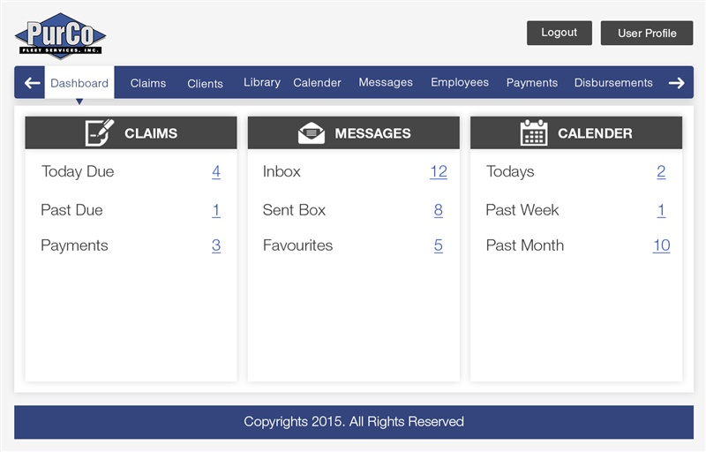

*Exhibit 3-1: System Dashboard showing capability and information (Ref 3.1.6)*

CMS Project Admin. Comments Pg. 6:

Seems redundant to have an icon and menu item. (Redesigned)

3.1 Claim Management System (CMS)

## 3.1.1 Clients

CLI-1: Client management: The System shall provide the ability to create new

clients, and update existing clients. The creation and update processes will

allow the entry of primary client information.

At a minimum, client information includes:

1. Primary contact information
2. Location and Address
3. Active vs Inactive status

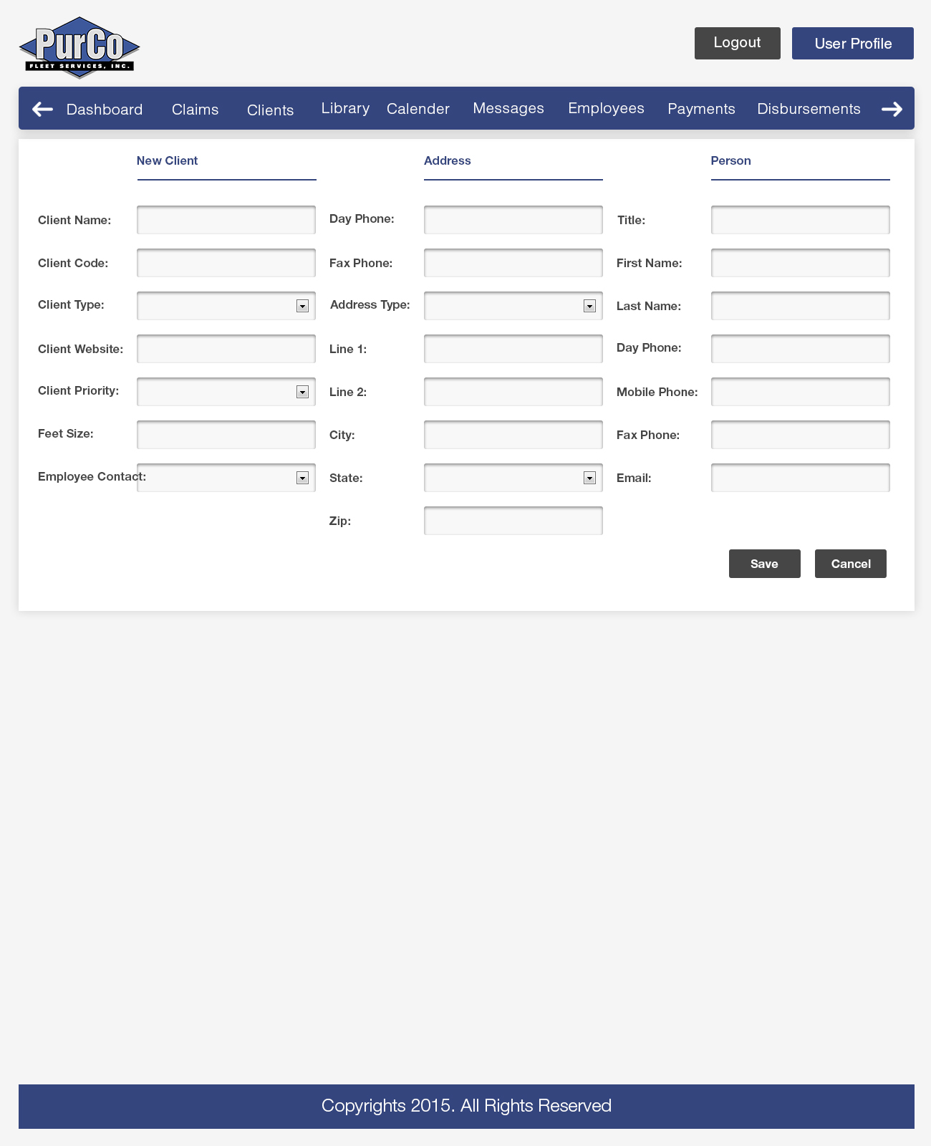

CMS Project Admin. Comments Pg. 7:

**Client Display Page/Client Contacts (main info page)**

Show what location this particular contact is over (this is new client entry view)

Can we get a check box (or something) for a Christmas list so that their info can be exported to an excel sheet. (That can be done)

Fields for both mailing address and physical address. (Address will have multiple entries)

*Exhibit 3-1.1: New Client interface pop-up, better UI and data validation (Ref CLI-1,CLI-2).*

CLI-2: Client contact management: The System shall provide the ability to manage

client contacts. Client contact information should be viewable from the claim.

Contact management includes the following operations:

1. Adding new Contacts for a Client.
2. Updating existing Contacts.
3. Removing Contacts for a Client.
4. Permissions Management.

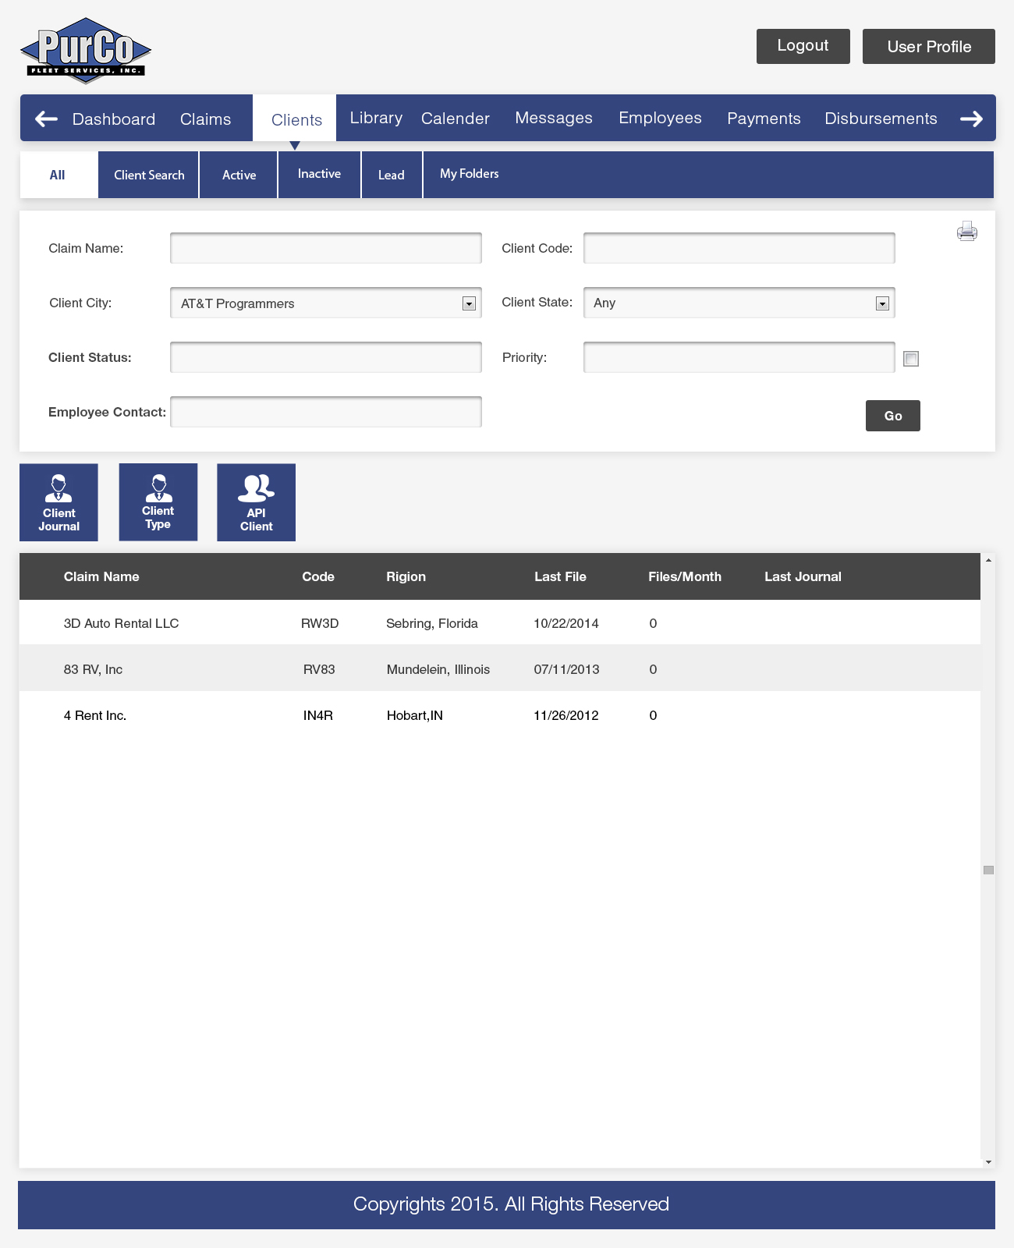

CMS Project Admin. Comments Pg. 8:

Does the add user button mean the same thing as add client? (Removed)

Do we need an All tab and Client Search tab? Can it all be combined into one tab? (Keeping it for familiarity with current CMS system)

*Exhibit 3-1.2: Clients screen integrating existing features better UI and additions (Ref CLI-2)*

CLI-3: Client directory interface: The System shall provide the ability to:

1. Search for a Client by name or other client information fields.
2. List all Clients, sortable by client information fields.

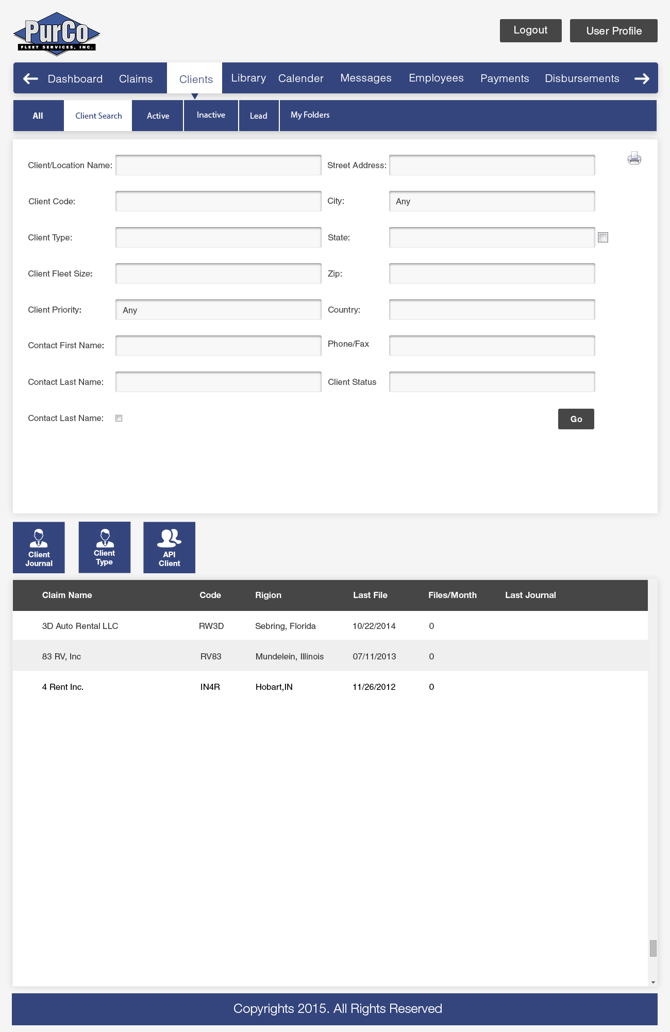

CMS Project Admin. Comments Pg. 9:

What prints when you click the print button?

(List output)

*Exhibit 3-1.3: Clients directory screen integrating search/list clients (Ref CLI-3)*

CLI-4: Client interaction history: The System shall provide a record of interactions with

a Client from multiple channels where supported. The interaction history shows

significant communications and events pertaining to a Client.

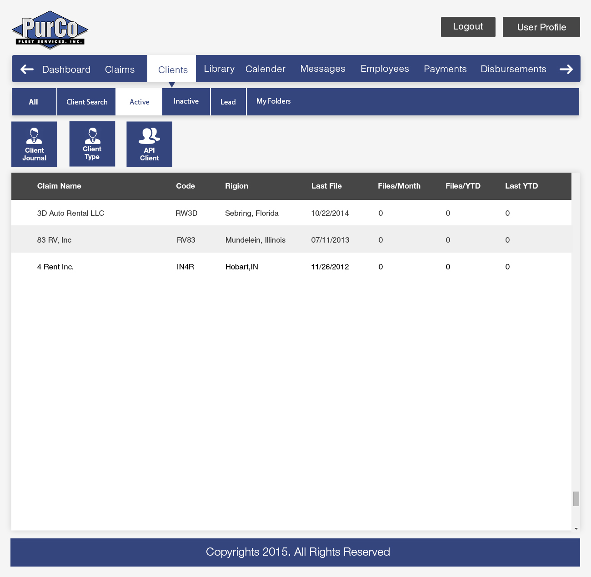

CMS Project Admin. Comments Pg. 10:

There isn’t a client type column or fleet column. Not sure if they need to be there or not. (?)

*Exhibit 3-1.4: Clients screen showing activity status and history available by clicking on client (Ref CLI-4)*

CLI-5: Client notes: The System shall provide the ability to add Notes to a Client.

Notes contain information and instructions. Note access will be controlled by

Permissions Management and will have limited visibility, based on Permissions.

CLI-6: Client resource management: The System shall provide the ability to manage

Resources. Resources are file attachments. Resources have settings to control

their visibility on Claims and websites. Resources should be able to be

assigned to claims.

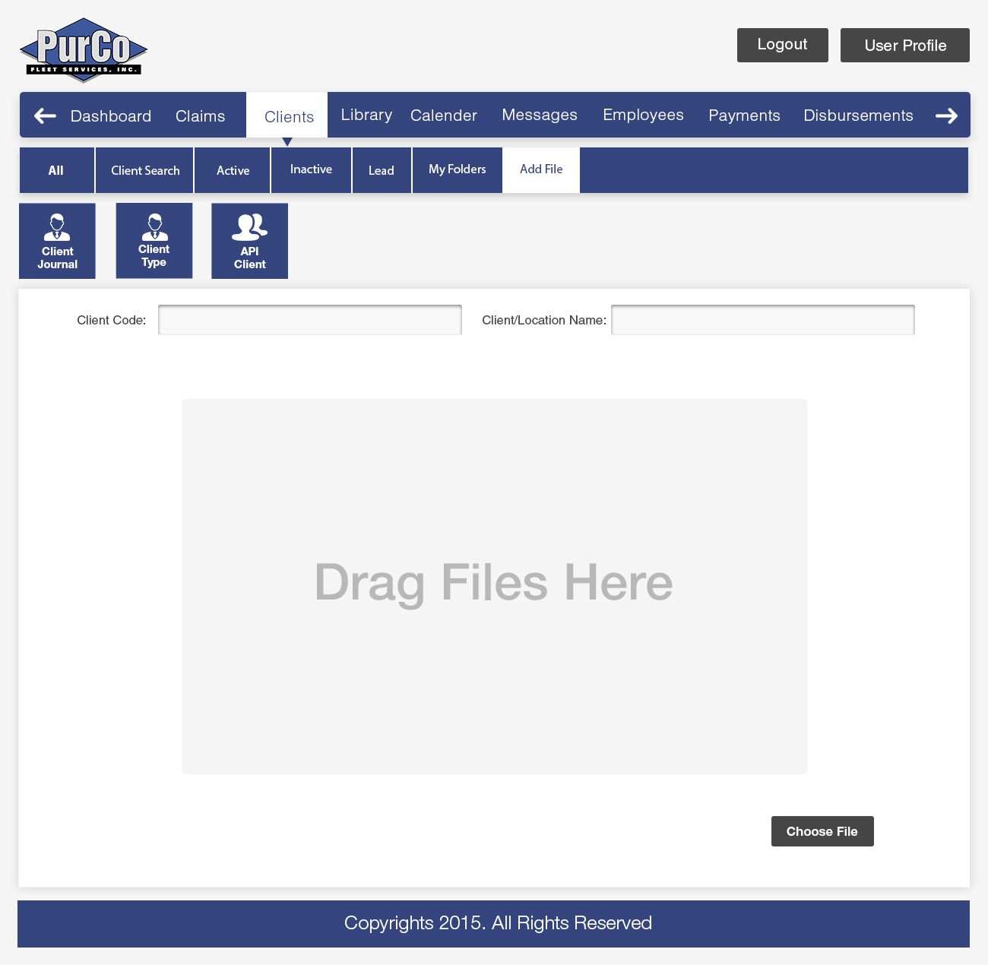

CMS Project Admin. Comments Pg. 11:

What is this page? Not sure what it does. (Client Resources- Drag n Drop Feature)

*Exhibit 3-1.5: Clients screen integrating drag / drop feature in browser for resource management (Ref CLI-5, CLI-6)*

## 3.1.2 Claim Types

TYPE-1: Claim Type management: The System shall provide the ability to

manage Claim Types. Claim Types can be created and configured at a system

level, and then customized on a per Client basis.

Claim Type management includes the following operations:

1. Adding and editing Claim Types.
2. Creating Disbursement rules.
3. Adding custom summary data.
4. Limiting which types of Payments are accepted.
5. Limiting which Letters are available for communications.
6. Associating Client Resources which are applicable for this Claim Type.

TYPE-2: Claim Type change history: The System shall provide an audit log of all

changes to a Claim Type.

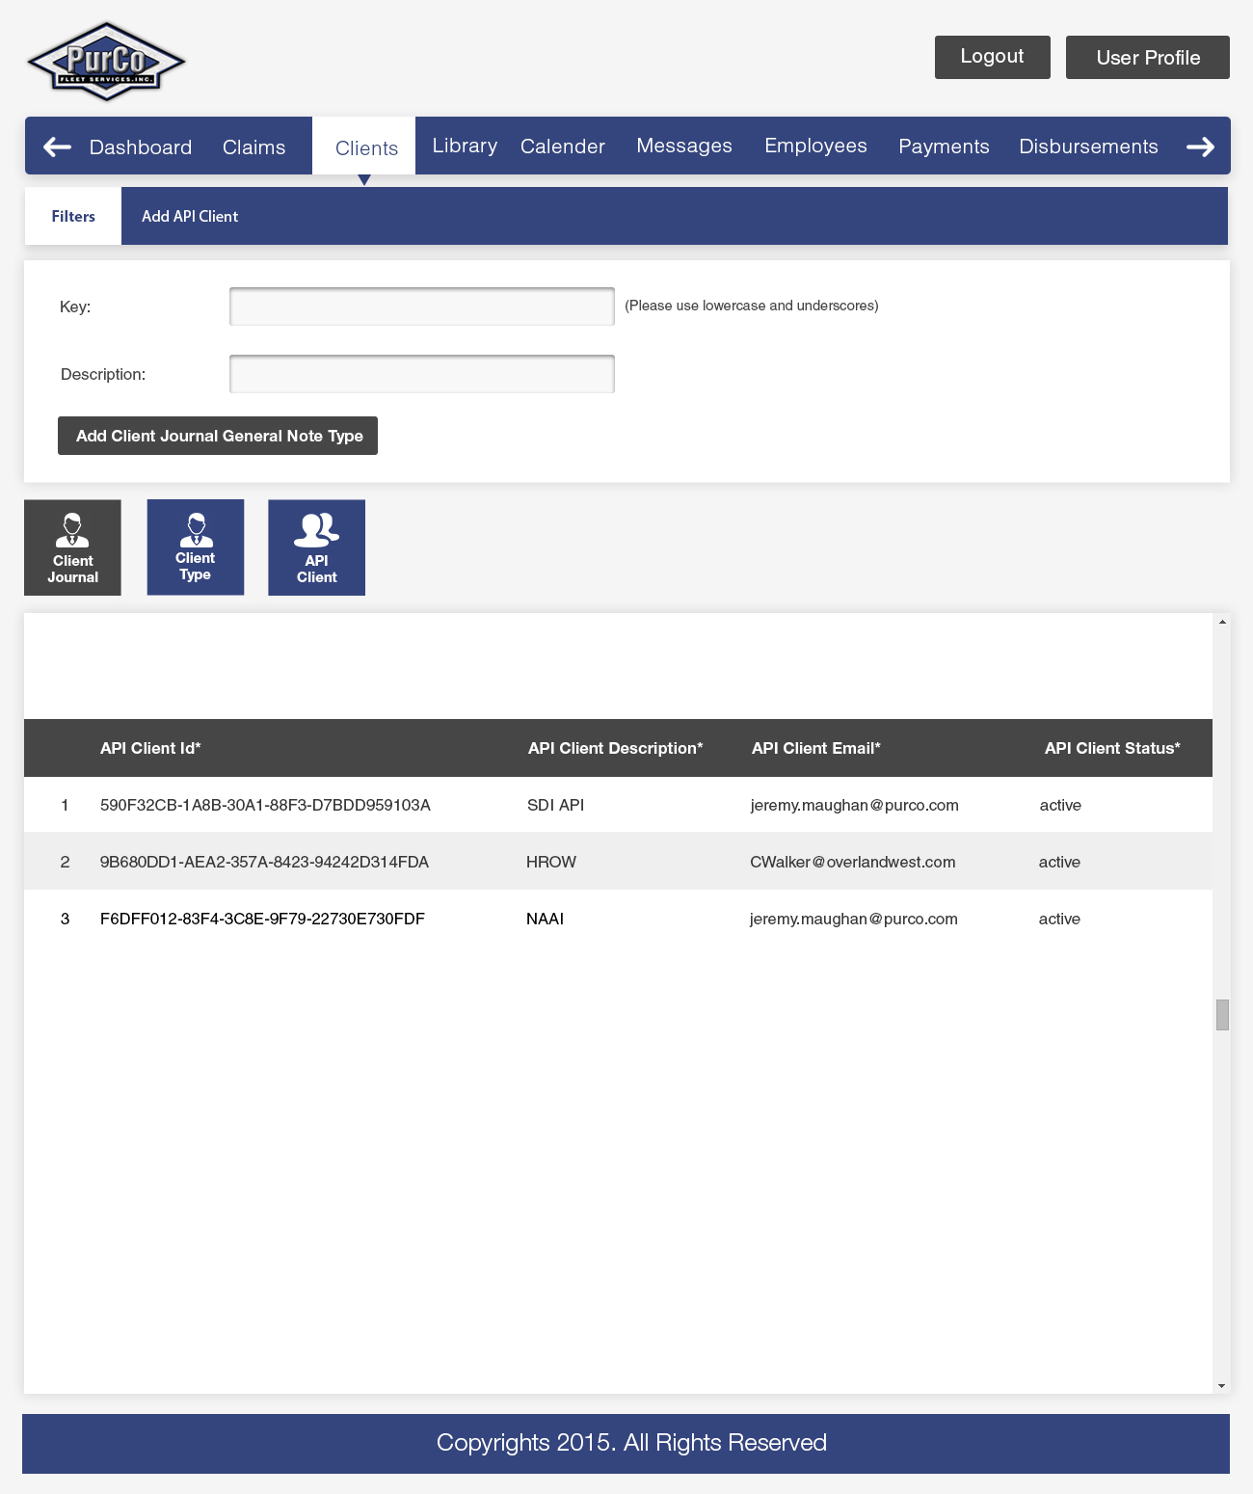

*Exhibit 3-1.6: Add Claims types screen integrating existing features better UI and validation (Ref Type-1/2)*

## 3.1.3 Claims

CLAIM-1: New Claim entry: The System shall provide the ability to create Claims.

Claim creation shall be governed by business rules which control the Claim

information including (part of this list are form fields):

1. Available Claim Types dependent on the Client.
2. Available Employees to which to assign.
3. Location of loss.
4. Date of loss.
5. Received date.
6. Completed date.
7. Insurance status.
8. Claim Status (with the addition of having granular status within claims for individual amounts)
9. Client Claim Number
10. Insured Information
11. Custom Data Value depending on Client Claim Type
12. Duplicate Claim checking as part of new entry
13. Client
14. Location
15. Assigned Employee
16. Vehicle Number
17. RA Number
18. Client Claim Number
19. Received Data
20. Date of Loss
21. VIN
22. Renter Information
23. Vehicle Information (Year / Make / Model)
24. LDW Status (Loss Damage Waiver)
25. Damage Description (Measurement Types & Free Text)
26. Overview
27. Information Needed (Outstanding)
28. Story
29. Journal Note
30. Claim Amounts (Including Breakdowns such as Daily Rate, Repair Hours, Loss of Use [LOU], AF calculations, Physical Damage)
31. Claim Status
32. Complete Date
33. Redaction Process (TBD)
34. New field for ORIGINAL CLIENT VALUES for Retail costs vs. Wholesale for repairs (hidden from CS)

CMS Project Admin. Comments Pg. 14 (New Pg. 13):

Involved Party tab, please make sure the information boxes follow the same order as the renter information boxes. (OK)

A bigger story box would be nice. I would like to see more than a couple lines of the story at once. (Will incorporate suggestion)

Is it possible to add a function that adds PD and Labor hour amounts together? (Yes)

Example: They send two invoices, one for the tire one for the rim. Instead of adding them on the calculator, could we add them together in CMS directly? Kind of like QuickBooks.

It would be nice to have a drop down menu to make a journal note a general note instead of having to make the note after the claim is set up or changing the journal note to a general note after the claim is saved. (A fixed list of items in dropdown is better approach)

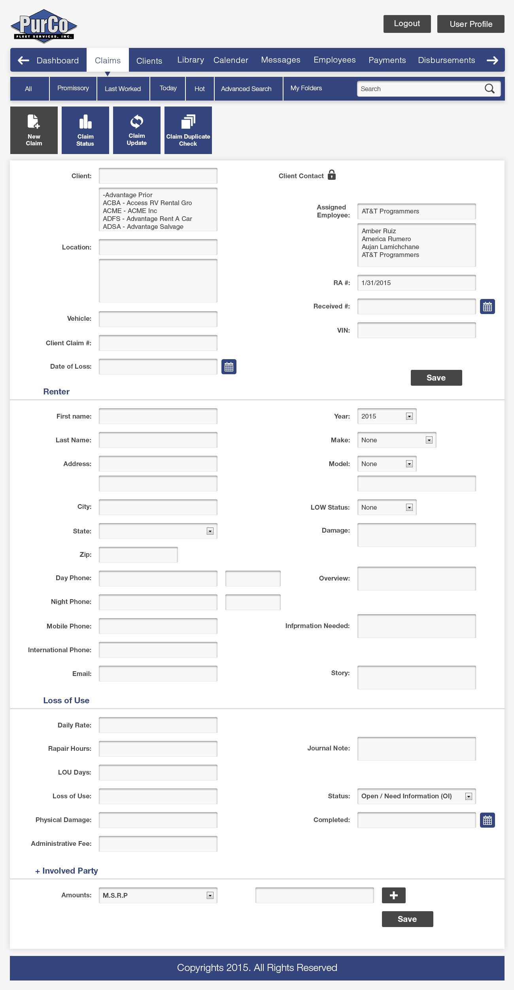

*Exhibit 3-1.7: Add Claims screen integrating existing features better UI and validation for duplicates* (Ref CLAIM-1, CLAIM-2, CLAIM-3)

CLAIM-2: Claim update: The System shall provide the ability to update Claims.

Claim updates shall be restricted based upon business rules and Permissions

of users performing the update. Users will be able to update Additional Parties

and Claim mounts.

CLAIM-3: Claim duplicate check: The System shall provide the ability to check for

duplicate claims based on Client Claim Number. Process should happen as

early as possible in the workflow and should check against Client Claim

Number, RA#, and/or Vehicle Number.

CLAIM-4: Claim filter: The System shall provide the ability to filter Claims based on

various criteria, allowing Employees to quickly find relevant Claims.

Filters which can be applied to Claims include:

1. All (Open)
2. Claim Status
3. Statute
4. Priority
5. Promissory
6. Last Worked
7. Today
8. Hot / Warm / Cold
   1. With Reason
9. Last Worked
10. Client Name
11. Employee

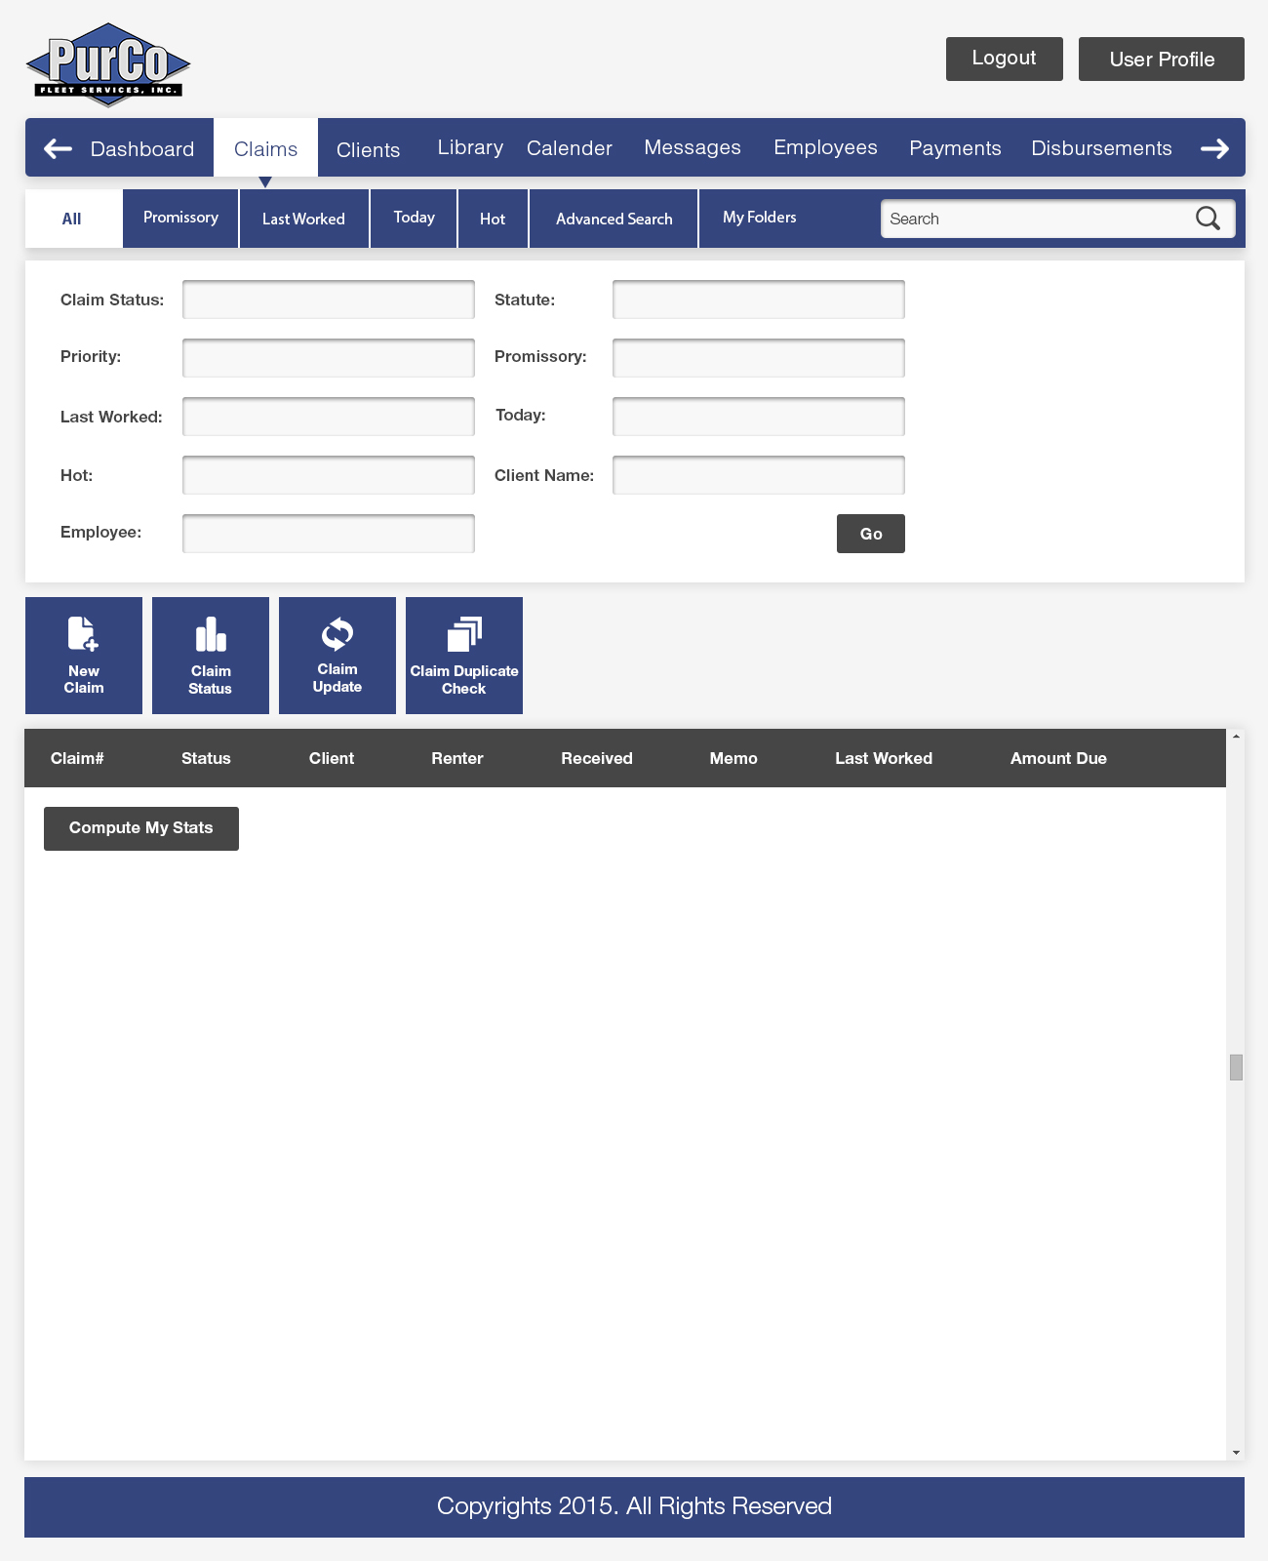

CMS Project Admin. Comments Pg. 16 (New Pg. 15):

Why are all the search boxes the same size? It looks funny, I don’t love it. (Redesigned, Added Advanced search screen for further search options 3-1.8b)

*Exhibit 3-1.8a: Claims view screen integrating existing features, filters, better UI and search (Ref CLAIM-4, CLAIM-5, CLAIM-10, CLAIM-11 and CLAIM-12)*

CLAIM-5: Claim search: The System shall provide the ability to search for Claims.

Claims shall be searchable by the majority of Claim information.

An optimized interface shall be provided to search for a Claim by claim number,

which will include best possible tab order, consolidated contact data, and cross file search capability, as well as a unified Journal with jump links to sections.

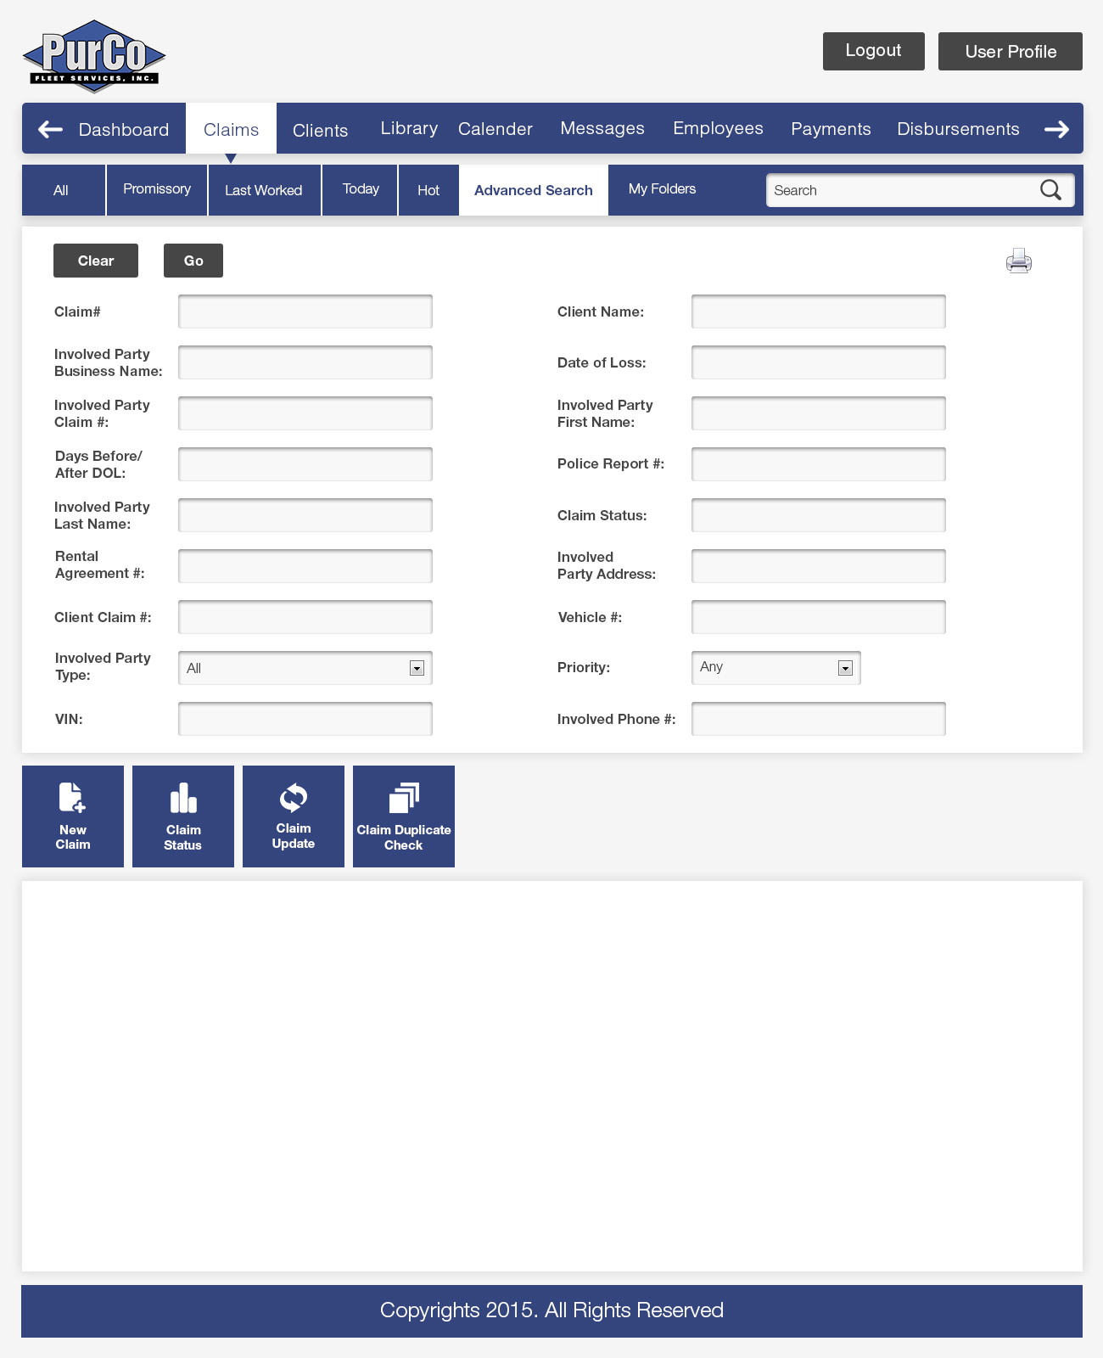

*Exhibit 3-1.8b: Claims Advanced Search integrating more search filters (Ref CLAIM-4, CLAIM-5, CLAIM-10, CLAIM-11 and CLAIM-12)*

CLAIM-6: [SDI & PurCo] Statute of Limitation view: The System shall provide a

mechanism for alerting employees of Claims that are approaching the Claim’s Statute of Limitation (via a more accurate calculation)

Employees must acknowledge this view before proceeding to use the System.

There should be a better visual color metaphor for aging of SOL.

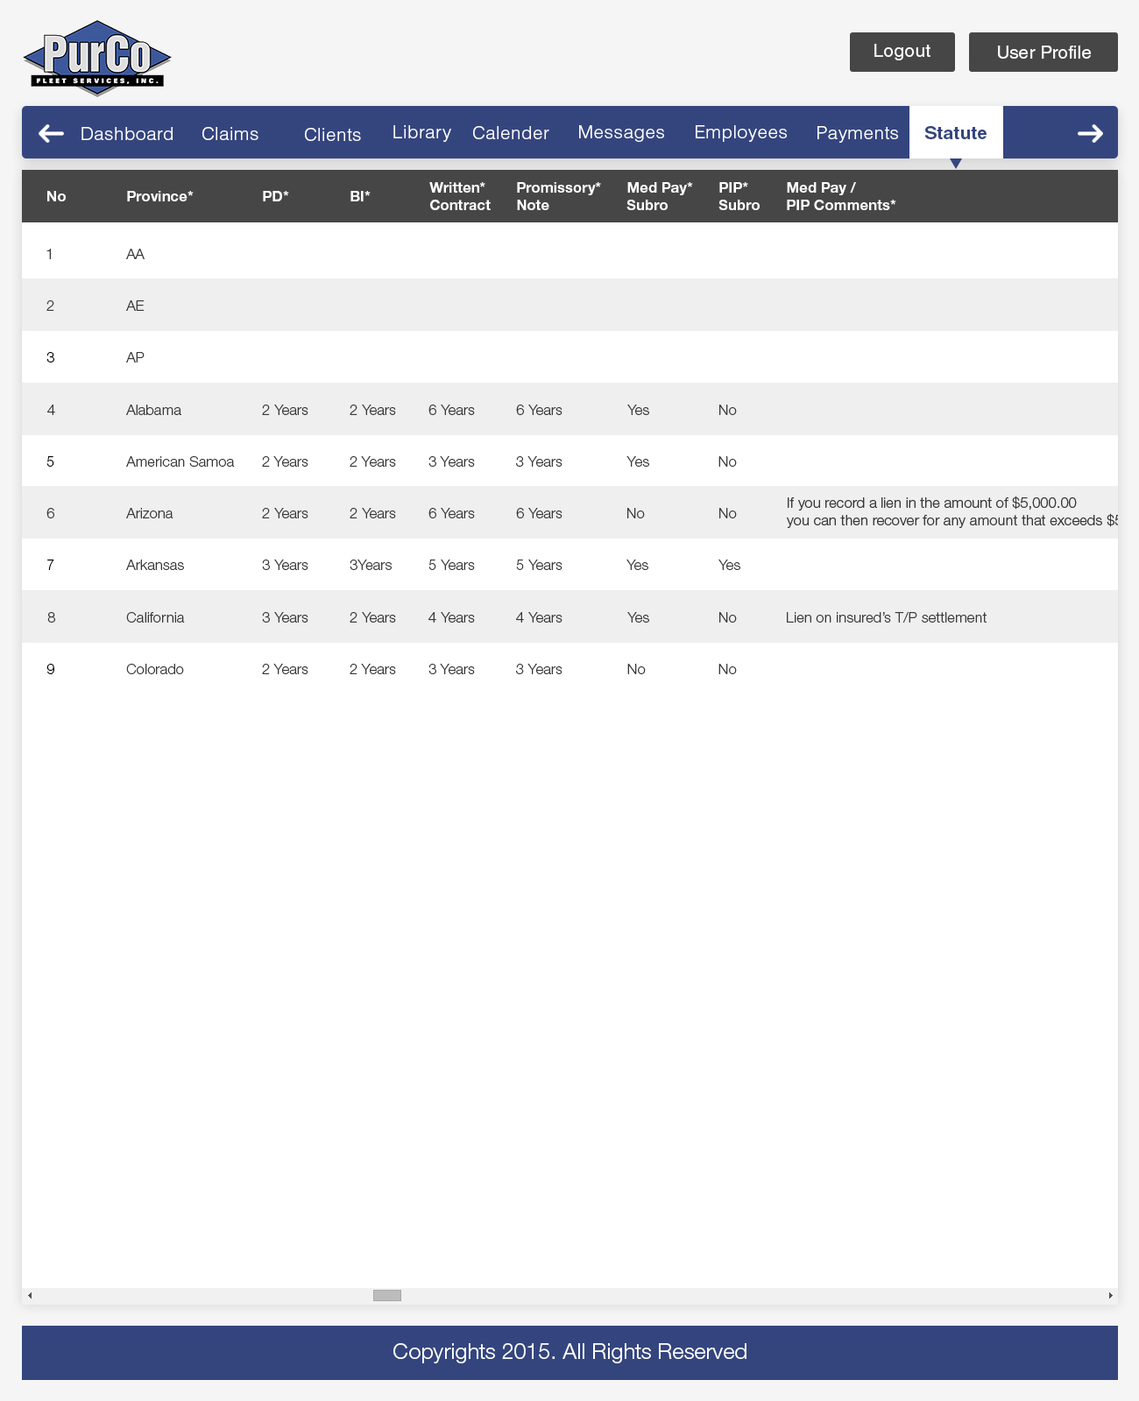

*Exhibit 3-1.9: Statute of Limitation screen showing top view and added drilldown feature for claims (Ref CLAIM-6)*

CLAIM-7: Promissory view: The System shall provide a mechanism for viewing Claims

with payments that are past due.

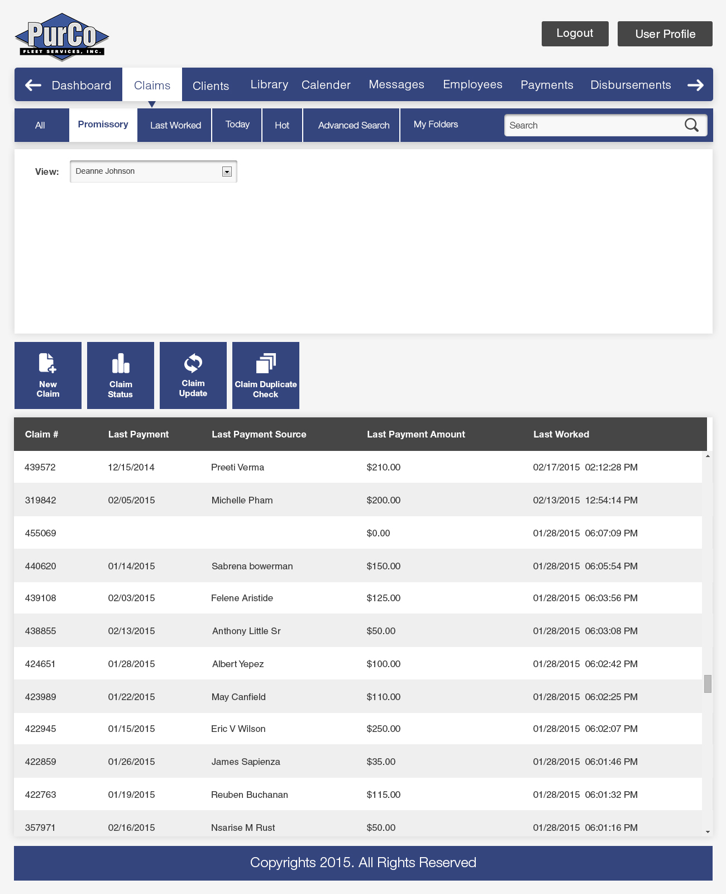

*Exhibit 3-1.10: Promissory screen integrating existing features better UI (Ref CLAIM-7)*

CLAIM-8: Today view: The System shall provide a mechanism for viewing Claims

worked by an employee on the current day (with the ability to put in a date

range).

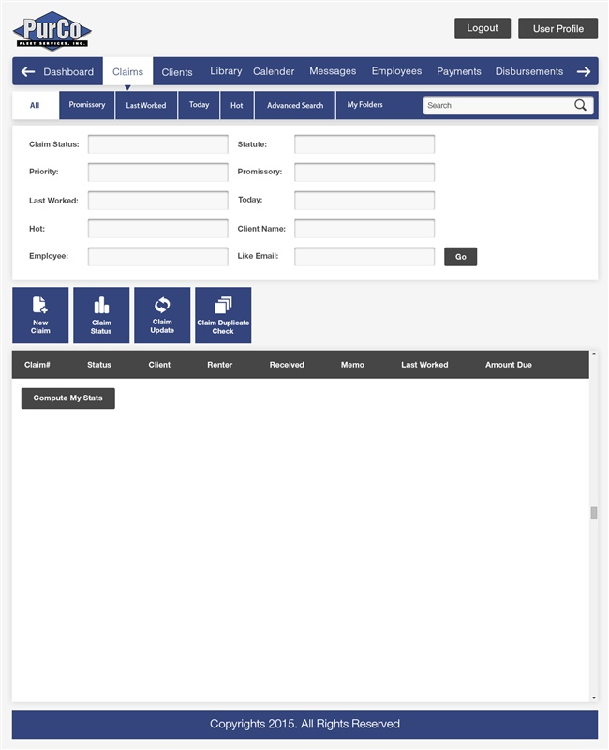

CMS Project Admin. Comments Pg. 19:

Can we get a search box for email addresses? It needs to be a box that searches “like” email

addresses so that you can search for just a name in the email address and it would pull up

any email address with that name in it. (Added)

Does the phone number need to be entered with or without dashes when searching? Once we get the new system all current employees will know, but an i.e. note for future employees would be helpful. (Standard Format ###-###-#### dashes auto included)

*Exhibit 3-1.11: Today screen integrating existing features and date range (Ref CLAIM-8)*

CLAIM-9: My Folders: The System shall provide a mechanism for ‘bookmarking’ pertinent

Claims for an Employee.

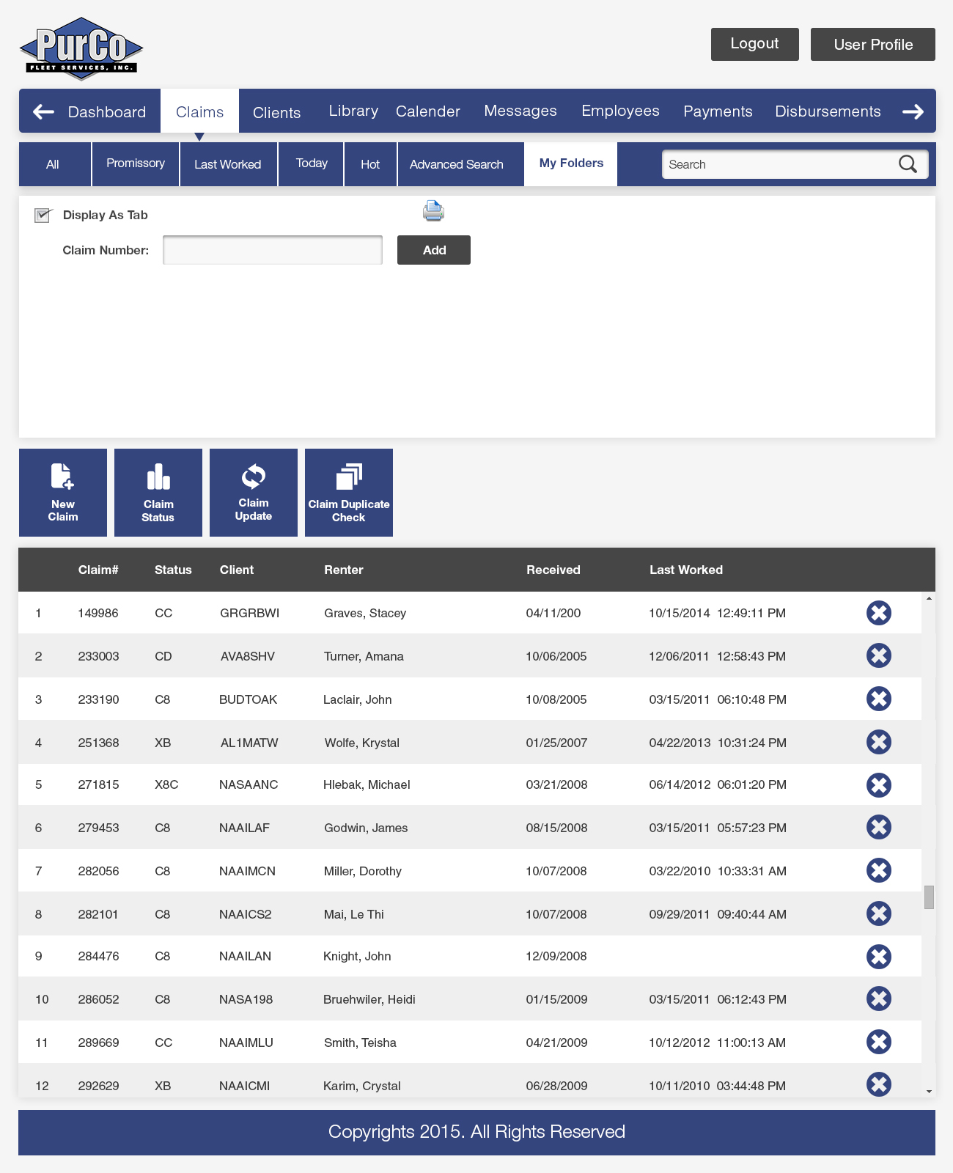

*Exhibit 3-1.12: Bookmarking screen integrating existing features (Ref CLAIM-9)*

CLAIM-10: Quick Client information view: The System shall provide the ability to view

Client information easily within a claim and provide a method to hide

information as necessary.

The Client information readily available within a Claim includes:

1. Client contacts.
2. Client notes.

CLAIM-11: Claim form validation: The System shall provide a mechanism for performing

deep validation of Claim information using business rules (with support for

lookup of existing value for involved party, adjuster, and other common

elements.)

CLAIM-12: Ability to track the partially closed claims at a granular level

## 3.1.4 Calendar

CAL-1: Calendar: The System shall provide a Calendar mechanism which integrates

deeply across multiple System modules. The Calendar view will allow

Employees to create and show events on particular days. Calendar can also

launch individual alerts and reminders for follow ups.

Calendar events include:

1. Claim follow-ups.
2. Upcoming Statute of Limitation expirations.
3. Small Claims dates.

The initial implementation of Calendar will not support external calendars

such as for State Courts.

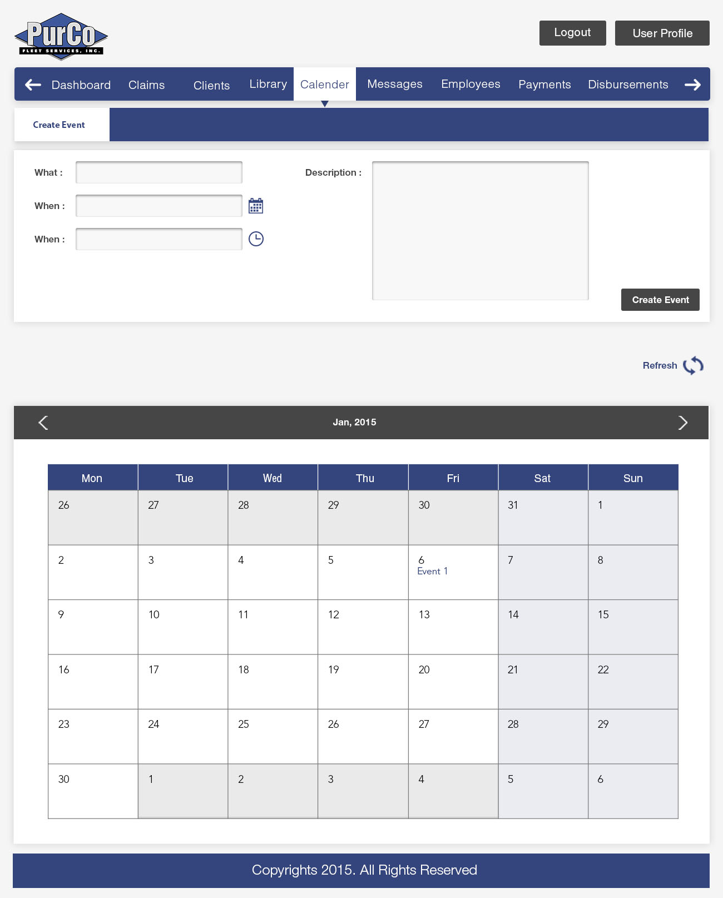

*Exhibit 3-1.13: Calendar screen view/add/edit events / automation UI (Ref CAL-1)*

## 3.1.5 Letter Templates

LET-1: Letter Template management: The System shall provide a mechanism for

creating and updating Letter Templates. Letter Templates are reusable

documents which contain placeholder references to mergeable information.

System will allow edits after merge.

LET-2: Mergeable Letter Template values: The System shall provide the ability to

merge System information with Letter Templates to create Letters.

Mergeable values include:

1. Claim information.
2. Client contact information.

LET-3: Scratchpad: The System shall provide the ability to create small notes

for commonly entered text.

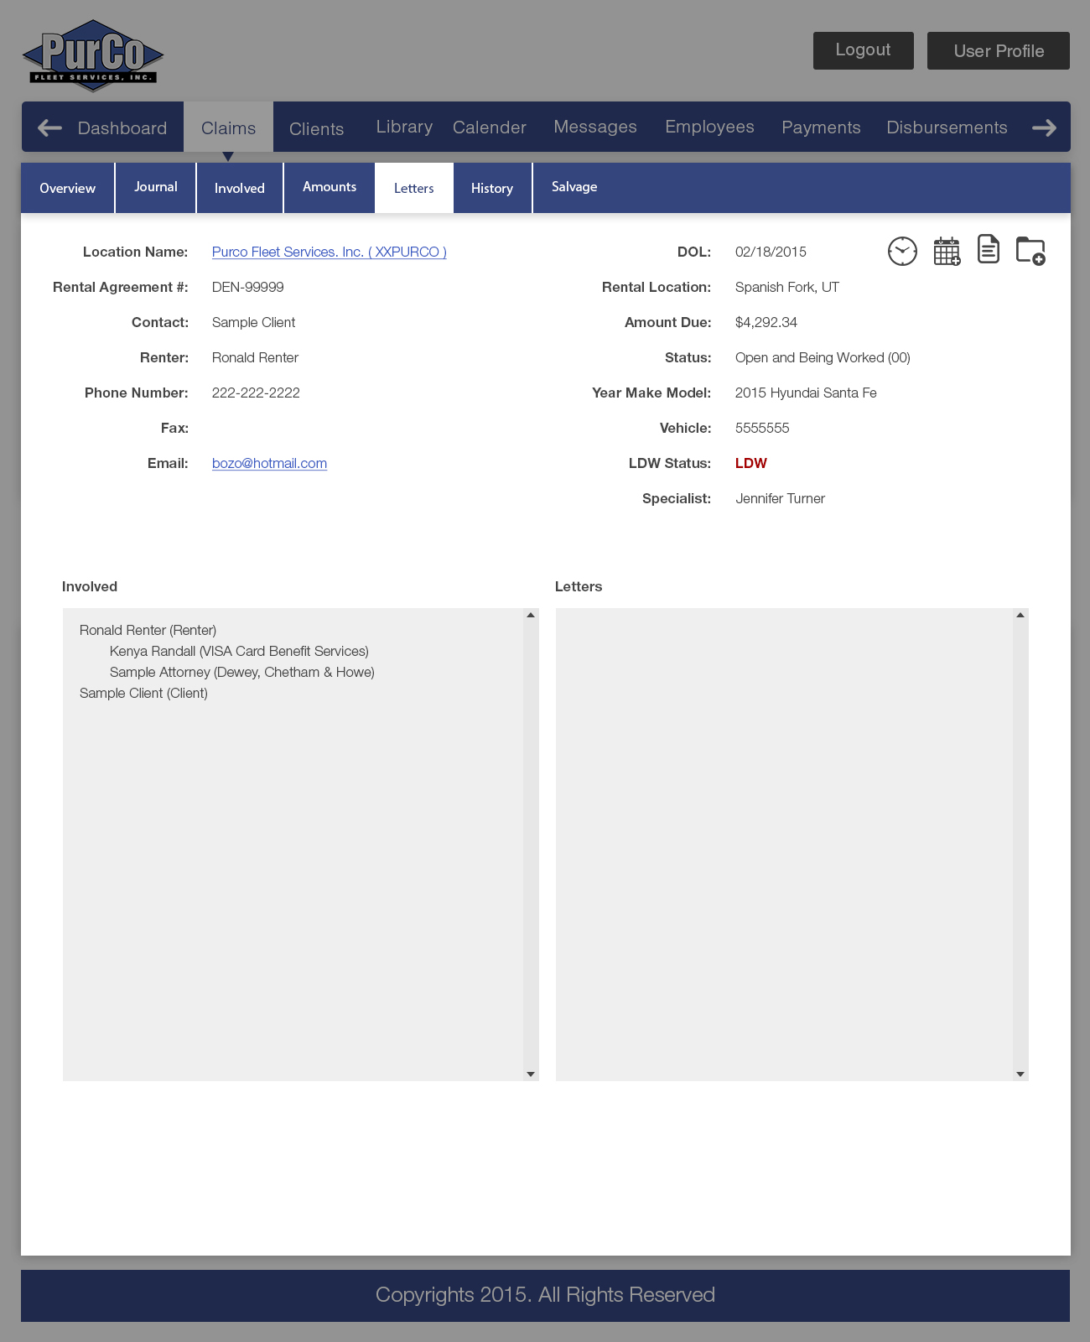

*Exhibit 3-1.14: Letter templates screen integrating new features and merge info (Ref LET-1/2/3)*

## 3.1.6 Dashboard

## 

DASH-1: Dashboard: The System shall provide a mechanism of displaying an overview

of System components to a User. This overview (along with the existing

dashboard items) constitutes the Dashboard. User can hide/unhide objects.

Performance metrics may include:

1. Close rate
2. Revenue
3. Cost Per
4. CN/CP/CD (Ability to calculate how much Claims Specialist is subsidizing their CN buy discounting fees)

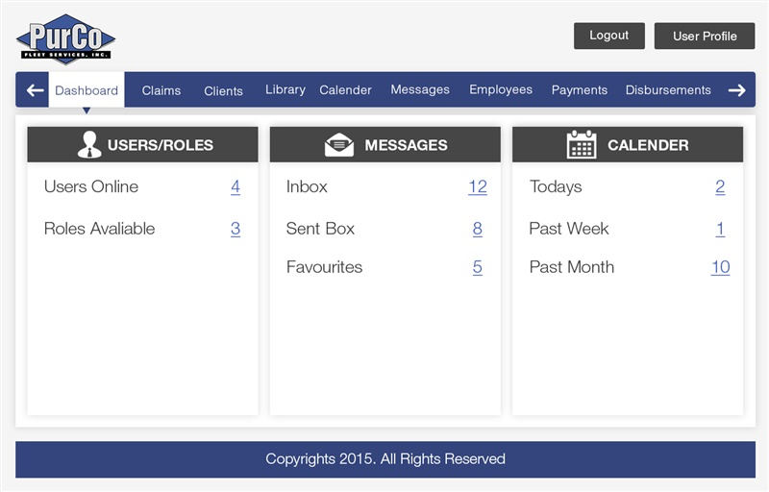

*Exhibit 3-1.15: System Dashboard showing capability and information (Ref 3.1.6)*

## 3.1.7 User Profile

PROF-1: Personal preferences: The System shall provide a mechanism allowing a User

to modify their personal settings (within the parameters of the Company policy),

contact information, and preferences.

Personal settings consist of:

1. Legal Name
2. Home Address Line 1
3. Home Address Line 2
4. City
5. State
6. Zip
7. Home Phone
8. Mobile Phone
9. Personal Email
10. Emergency Contact Name
11. Emergency Contact Phone
12. Spouse
13. Email signature.

Contact information consists of:

1. Address Line 1
2. Address Line 2
3. City
4. State
5. Zip
6. Phone
7. Fax
8. Email

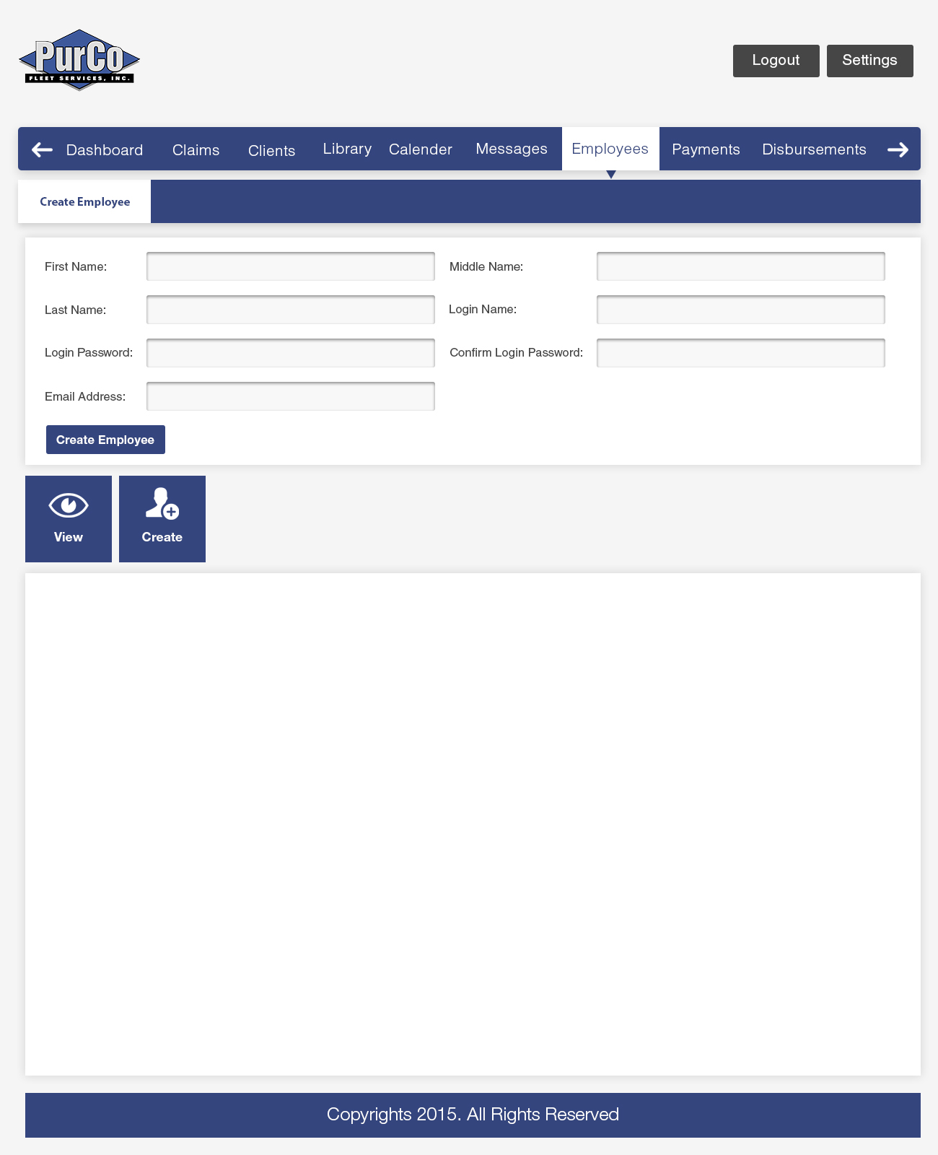

*Exhibit 3-1.16: User/Employee Addition with further popups for related information (Ref PROF-1)*

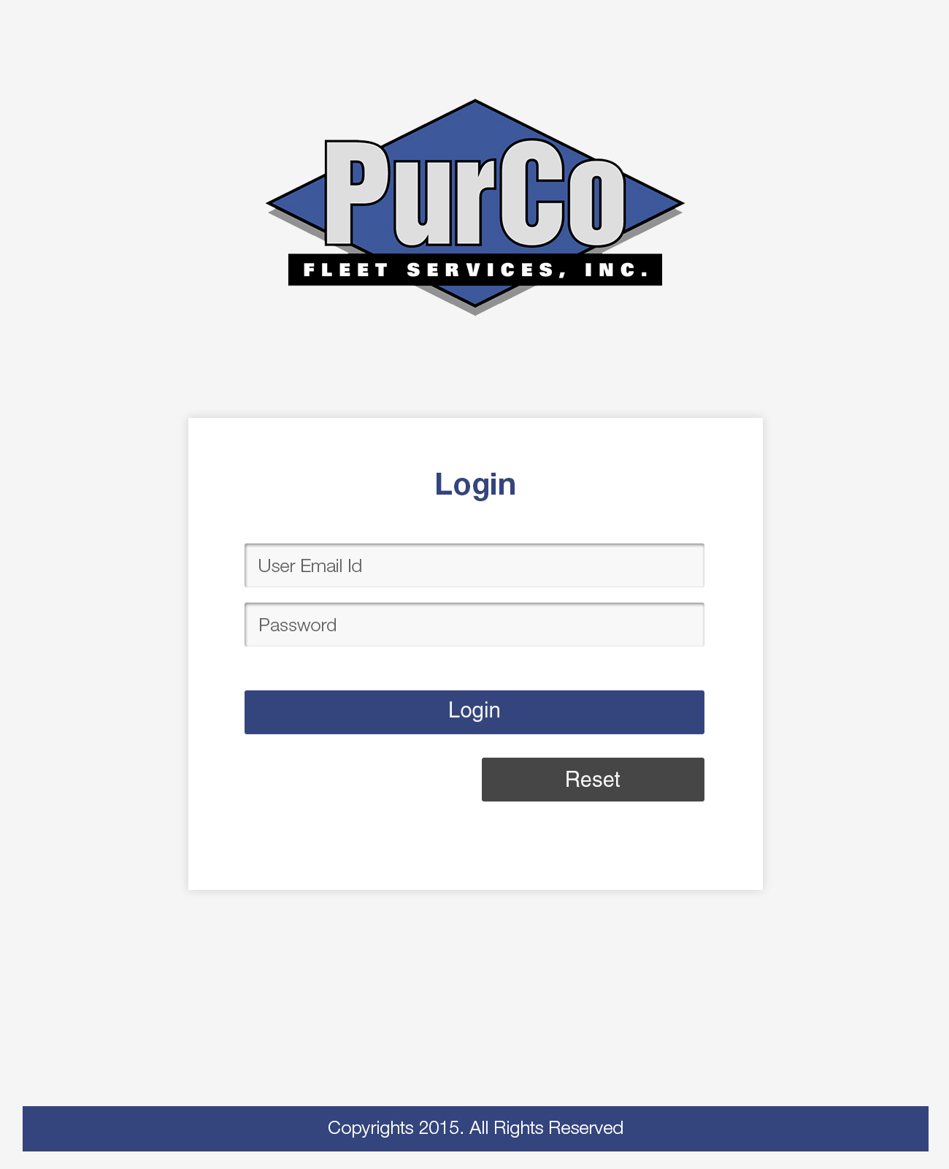

*Exhibit 3-1.17: Redesigned Logon Screen with improved UI (Ref PROF-1)*

<removed>

*Exhibit 3-1.18: Redesigned Screen with fresh registeration possible (Admin approved additions Ref PROF-1)*

PROF-2: System preferences: The System shall provide a mechanism allowing a User to

customize certain System preferences.

Customizable System preferences include:

1. Default Claim view.
2. Notification email address.
3. Default printer.
4. Email BCC preference.
5. Password.
6. Menu Order

## 3.1.8 Library

LIB-1: Library: The System shall provide a mechanism for storing and viewing

Documents between Users. A global Library of Documents allow

various documents to be uploaded. Access control to Documents will be

controlled by Permissions as required by Roles.

Documents in the Library may consist of content such as:

1. Legal information and case law.
2. State offices.
3. Statute of Limitation information.
4. Procedures for obtaining police reports.
5. Helpful letters.

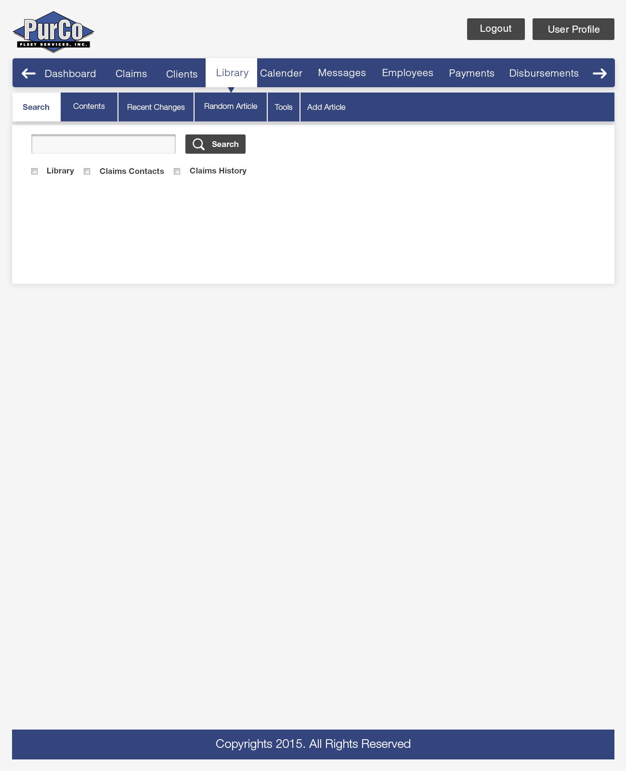

*Exhibit 3-1.19: Library interface for related legal and precedents information (Ref LIB-1)*

## 3.1.9 Payments

PAY-1: Payment entry: The System shall provide a mechanism for entering information

about Payments that have been received.

Received Payment information includes:

1. Received date.
2. Claim Number.
3. Payment Type (how payment was received)
4. Source.
5. Alternate source.
6. Check Number.
7. Check Date.
8. Check image attachment.
9. Amount.
10. Payment Method (money order / insurance check / personal check)
11. Visual notification for special cash handling rules

PAY-2: Payment Claim information accessibility: The System shall provide the ability to

view Claim information in a Payment after the Claim Number has been entered.

Claim information accessible within a Payment includes:

1. Insured status.
2. Client.
3. Specialist.
4. Status.
5. Amount Due.

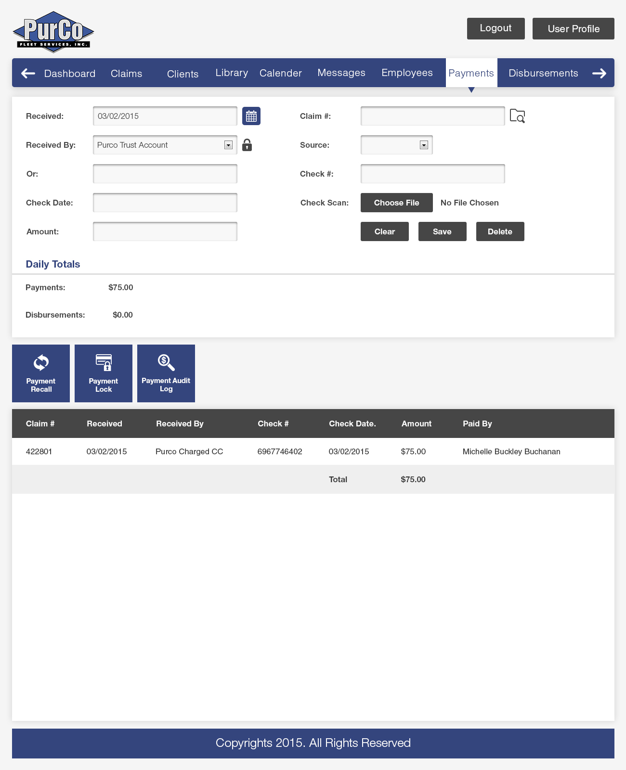

*Exhibit 3-1.20: Payment entry view with further popups for related information (Ref PAY-1/2/3/4)*

PAY-3: Limited Payment types in Payment entry: The System shall provide a

mechanism for limiting the available Payment types when entering a Payment.

PAY-4: Payment recall: The System shall provide the ability to recall a Payment. A

Payment may be edited or deleted.

PAY-5: Payment lock: The System shall provide a mechanism for locking a Payment,

disallowing Users from editing the Payment. Locking of Payments shall be

controlled by Permissions.

PAY-6: Payment audit log: The System shall provide a mechanism for creating

immutable records of each Payment entered. These records will be stored in

an audit log. Check scans or credit card receipts shall be associated with these

audit log entries.

PAY-7: Online Payments: The System shall provide the ability to receive Payments

online. Online Payments shall be entered into the Payment audit log. A receipt

will be created and attached to the audit log record.

## 3.1.10 Disbursements

DIS-1: Disbursement management: The System shall provide a mechanism to

manage Disbursements for a Claim. Management includes the creation,

investigation, and confirmation of Disbursements.

DIS-2: Payments list view: The System shall provide a mechanism for viewing all

Payments made for a Claim. The payment list shall be sortable on

multiple columns.

The Payments view will show the following information:

1. A list of Payments which is filterable by date range (default to current date).
2. Indication of Payment disbursement status.
3. Total Payment amount.
4. Total Disbursement amount.
5. Amount due.

DIS-3: Disbursement detail view: The System shall provide the ability to view the

details of Payments and the Claim in the context of a Disbursement.

The Disbursement detail view shall show the following Claim and Disbursement

information:

1. Claim amounts.
2. Claim Number (with link to Claim).
3. Contracted Disbursement %.
4. Claim Status.
5. Link to Client information.
6. Specialist.
7. Projected Disbursements.
8. Renter’s Name

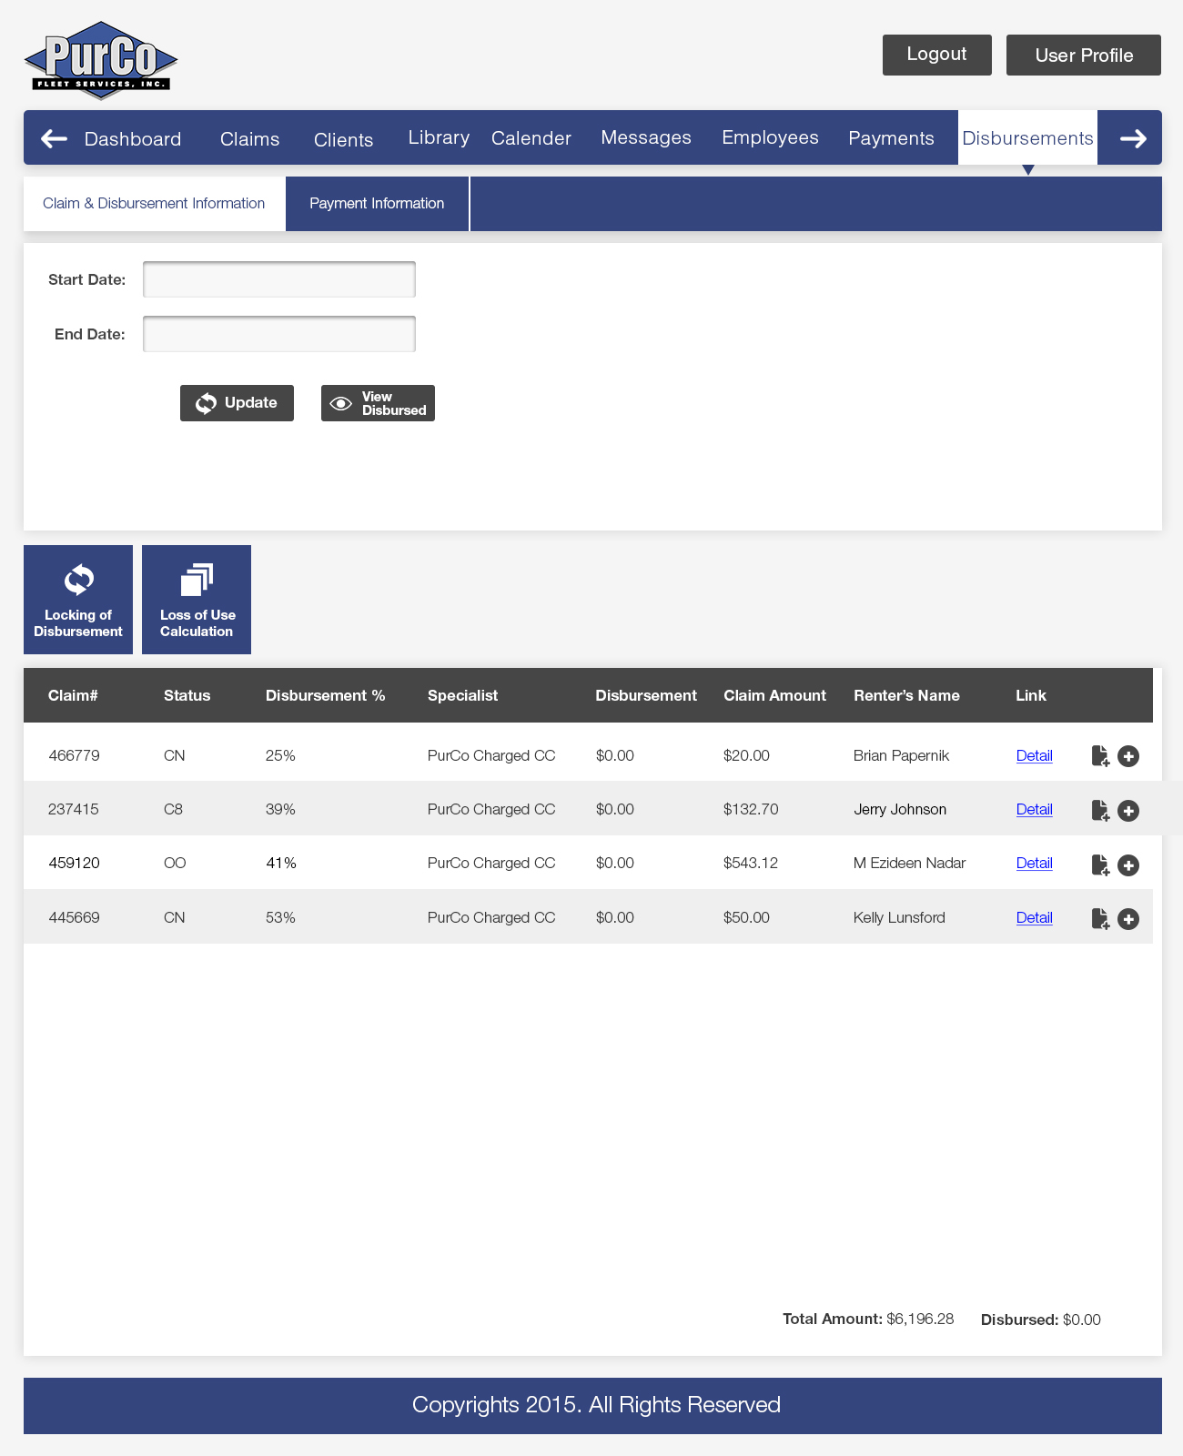

*Exhibit 3-1.21: Disbursement view for related information (Ref DIS-3)*

The Disbursement detail view shall show the following information for all

Payments made for a claim:

1. Payment type.
2. Check Number.
3. Check Date.
4. Source.
5. Payment Amount.
6. Amount Disbursed.
7. Total Payments
8. Total Disbursements.
9. Amount Due

The Disbursements detail view shall show a list view of Disbursements made

for the selected Payment. This list view shall be sortable on multiple fields.

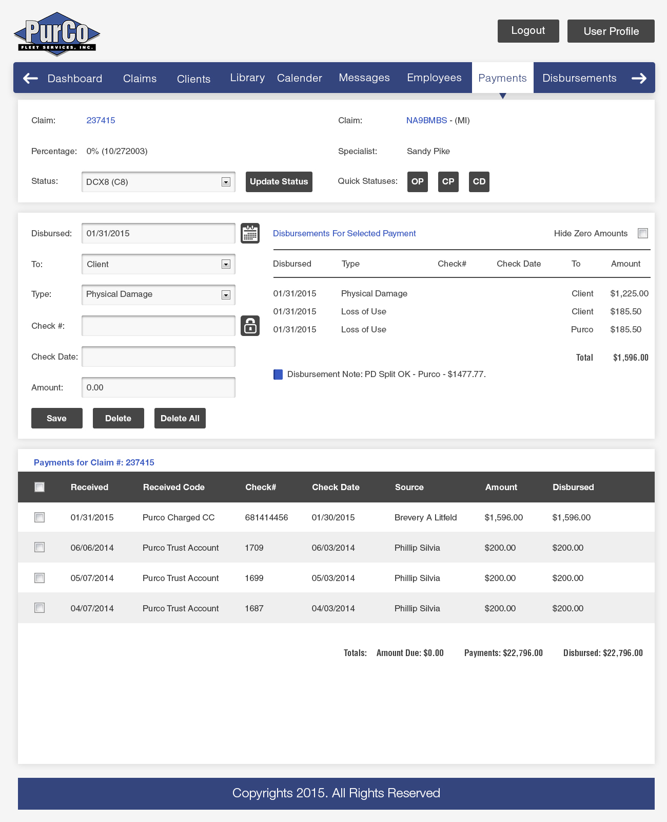

CMS Project Admin. Comments Pg. 28/30:

Where is the Amounts/Projected/Actual box? Also the box that lets you add more categories?

In the above mention box can we get it to calculate certain things for or us and put in the

amount automatically?

(Yes, can calculate entered amounts live but that auto calculated fields will not be editable)

Example: On a hertz 7% split once we enter the Client or PurCo amount in the projected box

could it automatically calculate the amount for the other party and enter it?

Under the source section could the Payee be editable? (Rules can be included on client setup)

*Exhibit 3-1.22: Payment disbursement summary view with further popups for related information (Ref DIS-2/3/4/5/6)*

DIS-4: New claim amount: The System shall provide a mechanism for adding a new

Claim amount during the Disbursement stage.

DIS-5: Add Disbursement to Payment: The System shall provide a mechanism for

adding a new Disbursement of a Payment.

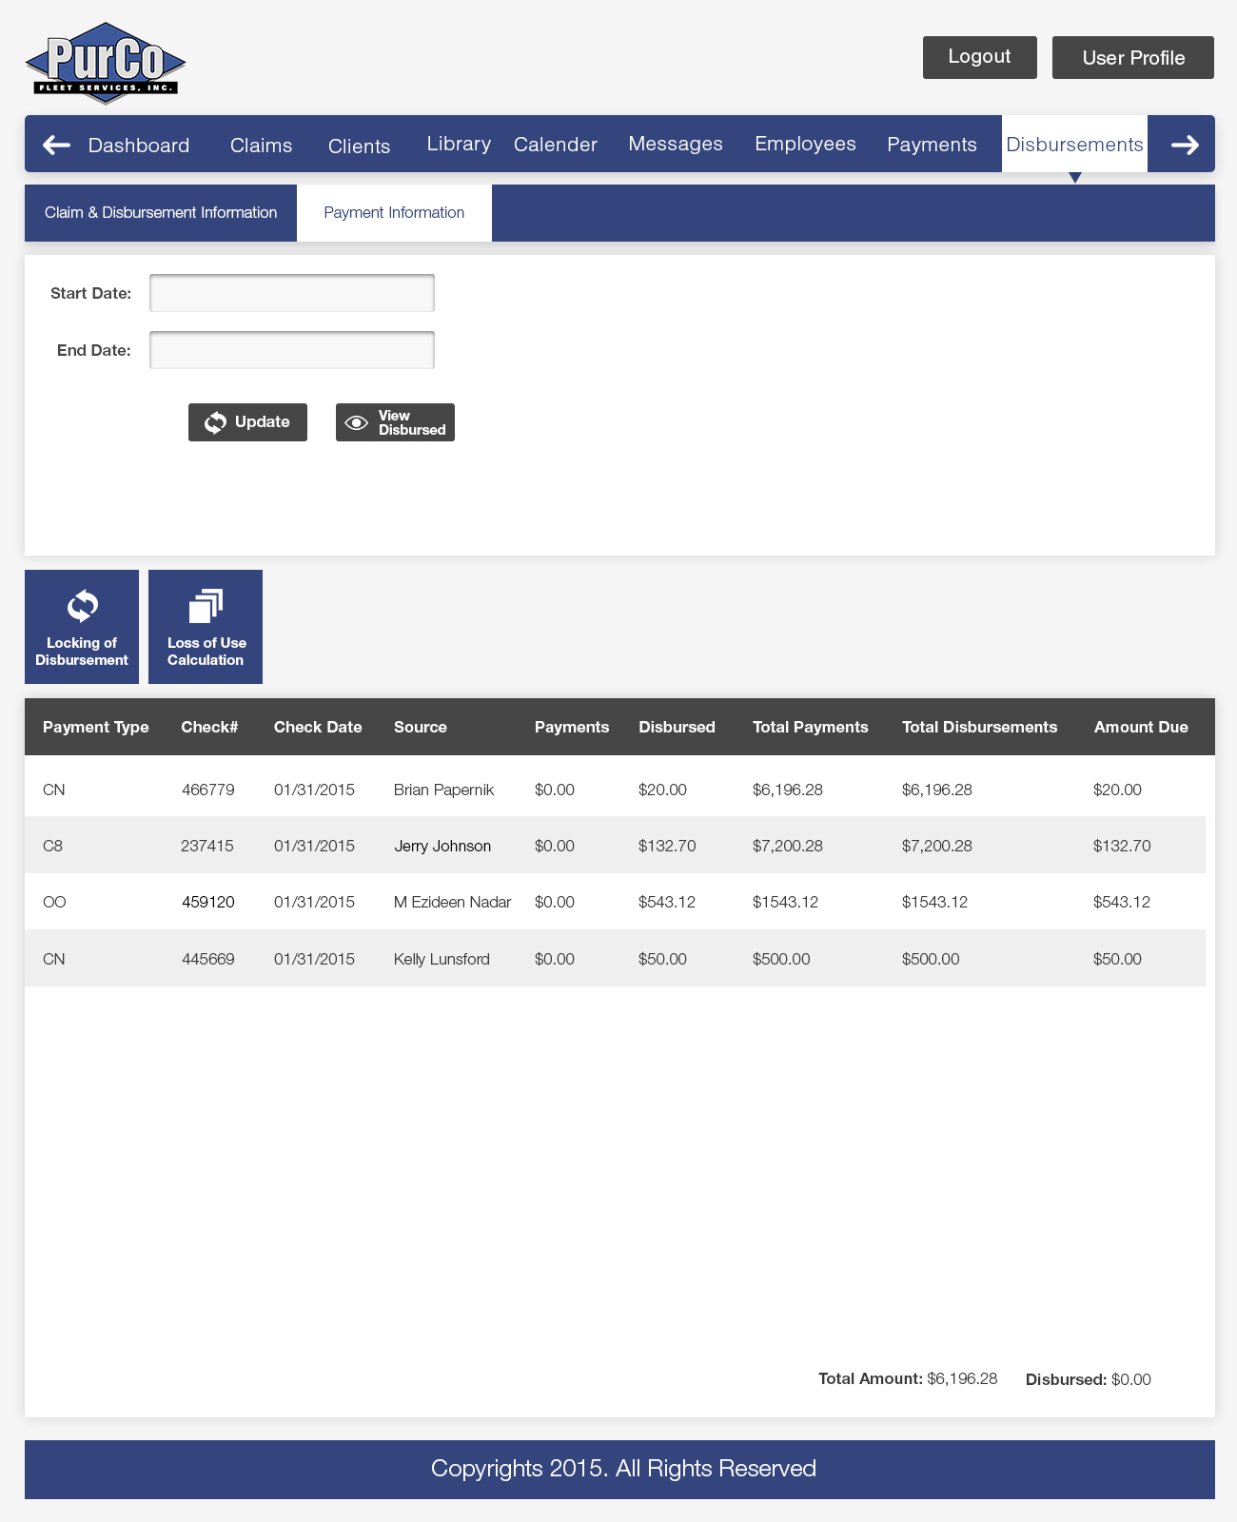

*Exhibit 3-1.23: Payment disbursement summary view (Ref DIS-5/6)*

DIS-6: Edit Disbursement for Payment: The System shall provide a mechanism for

editing a Disbursement of a Payment.

DIS-7: Delete Disbursement for Payment: The System shall provide a mechanism

deleting a Disbursement of a Payment.

DIS-8: Claim status change: The System shall provide a mechanism for affecting the

Claim Status.

DIS-9: Locking of Disbursements: The System shall provide a mechanism for locking

Disbursements. Locked Disbursements are read-only, and cannot be modified.

Locking controls shall be determined by business rules around Payments and

Client checks. Locking shall be able to be overridden by certain high level

Users, governed by Permissions.

DIS-10: Loss of Use calculation: The System shall provide a mechanism to calculate

Loss of Use in the context of a Disbursement.

DIS-11: Disbursement list view: The System shall provide the ability to see all

Disbursements for a Client.

The Disbursement list view will include the ability to navigate to the

Disbursement edit page for a selected Disbursement.

DIS-12: Client check information for Disbursements: The System shall provide a

mechanism for updating Disbursements with client check details after client

checks are issued. (Auto-fill support for the same payee)

Client check details updated for the Disbursements include:

1. Check number.
2. Check date.

DIS-13 Automatic disbursement: The System shall provide the ability to automatically

disburse a payment. An automatic Disbursement may be triggered when a

Payment amount matches a particular amount type exactly.

## 3.1.11 Employees

EMP-1: Add employee: The System shall provide a mechanism to add a new

Employee.

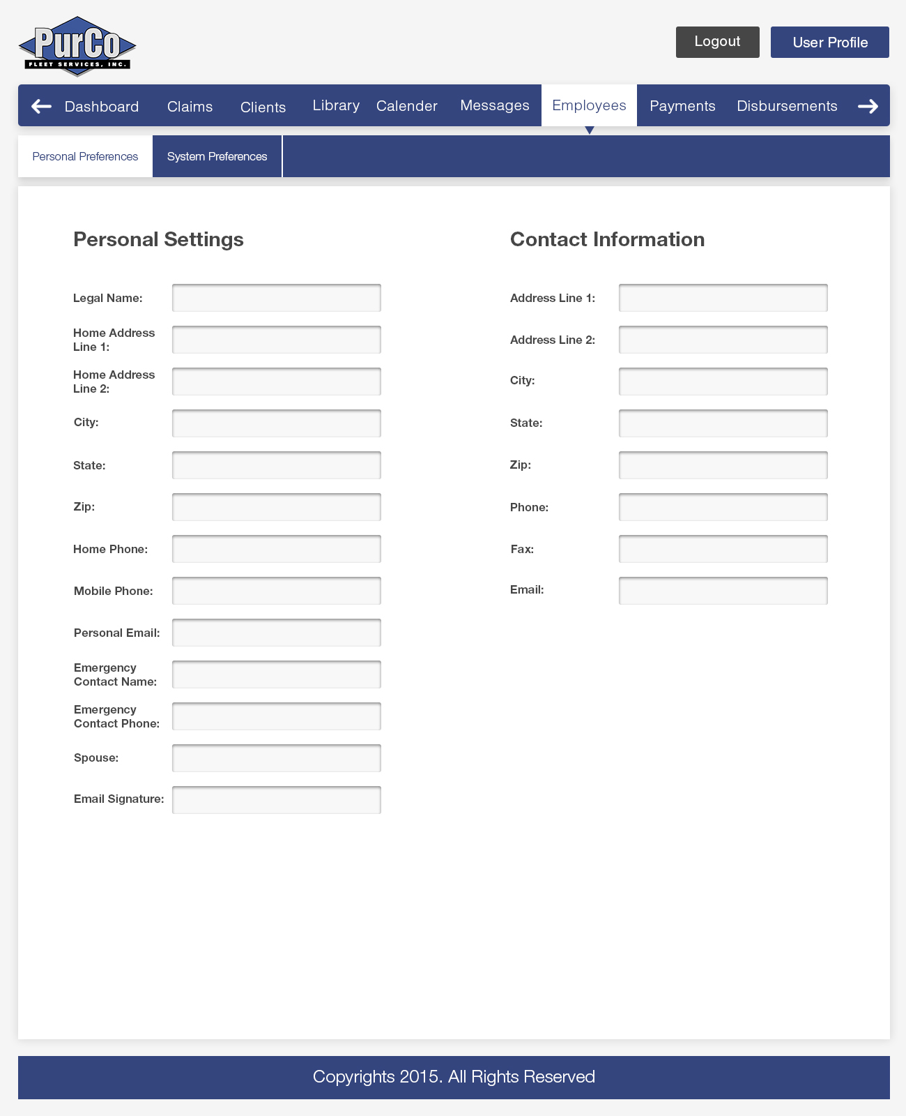

CMS Project Admin. Comments Pg. 33 (New Pg.34):

The big blue box/stripe is a little harsh. I don’t love the way it looks. (Redesigned)

*Exhibit 3-1.24: Employee profile view with further popups for related information (Ref DIS-2/3/4/5/6)*

EMP-2: Employee search: The System shall provide a mechanism to search for an

Employee.

EMP-3: View and edit Employee: The System shall provide a mechanism to view and

edit employee information. Visibility and editability of Employee information

shall be governed Permissions.

Employee details include the following information:

1. First Name
2. Middle Name
3. Last Name
4. Position
5. Employee Manager
6. Permissions
7. Active Status
8. Birthdate
9. SSN
10. License Number
11. License Date
12. Hire Date
13. Termination Date
14. Re-hire Date
15. Re-termination Date

The personal and contact Employee information visible in the My Profile section

(**PROF-1**) shall be viewable and editable by Authorized users in this interface.

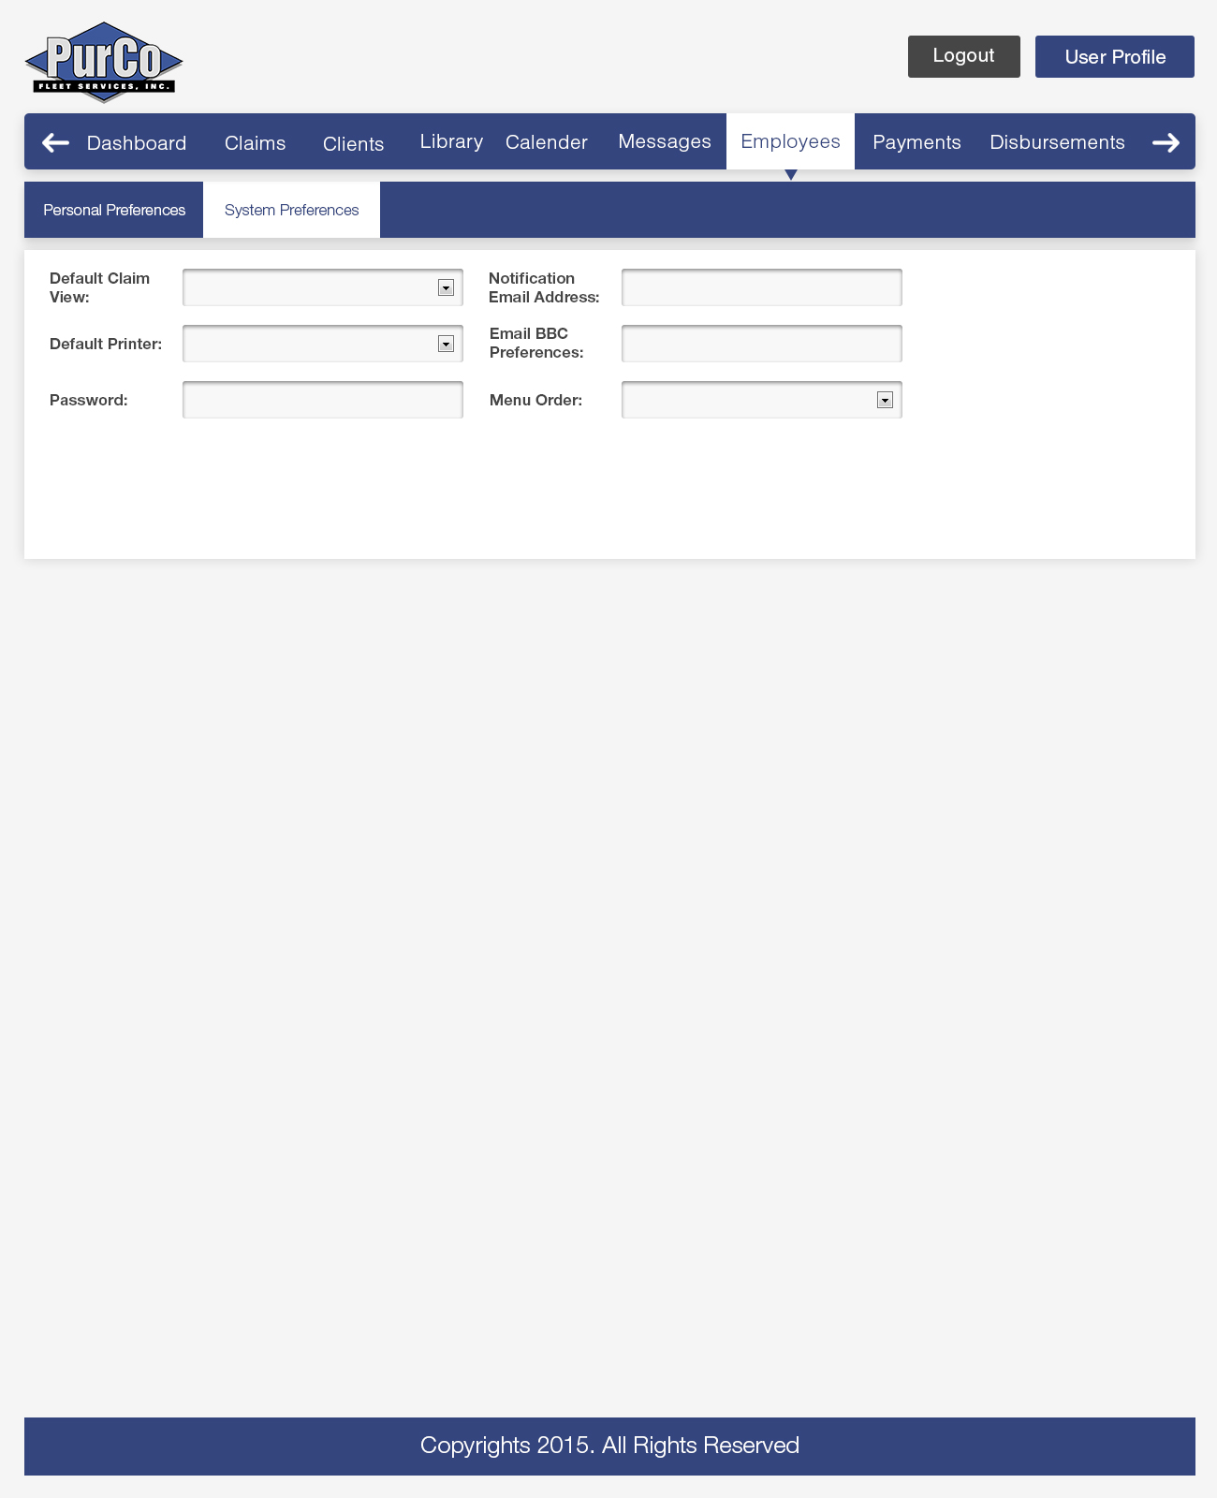

*Exhibit 3-1.25: Employee profile view with further popups for related information (Ref DIS-2/3/4/5/6)*

EMP-3: Administrator password reset: The System shall provide a mechanism allowing

an Administrator to reset the password for an Employee. Access to this feature

shall be governed by Permissions.

## 3.1.12 Reporting

REP-1: Create Report: The System shall provide a mechanism to create Reports.

REP-2: Import Report: The System shall provide a mechanism to import Reports.

REP-3: Export Reports: The System shall provide a mechanism export Reports.

REP-4: Report categories: The System shall provide the ability to assign categories to

Reports.

## REP-5: Pre-canned reports (example: Advantage)

REP-6: Dynamic reports: The System shall provide a mechanism for creating reports

dynamically. Dynamic Reports shall be available to Employees and Clients.

This will include required meta-data that explains the reason the report was created, by whom, and for whom.

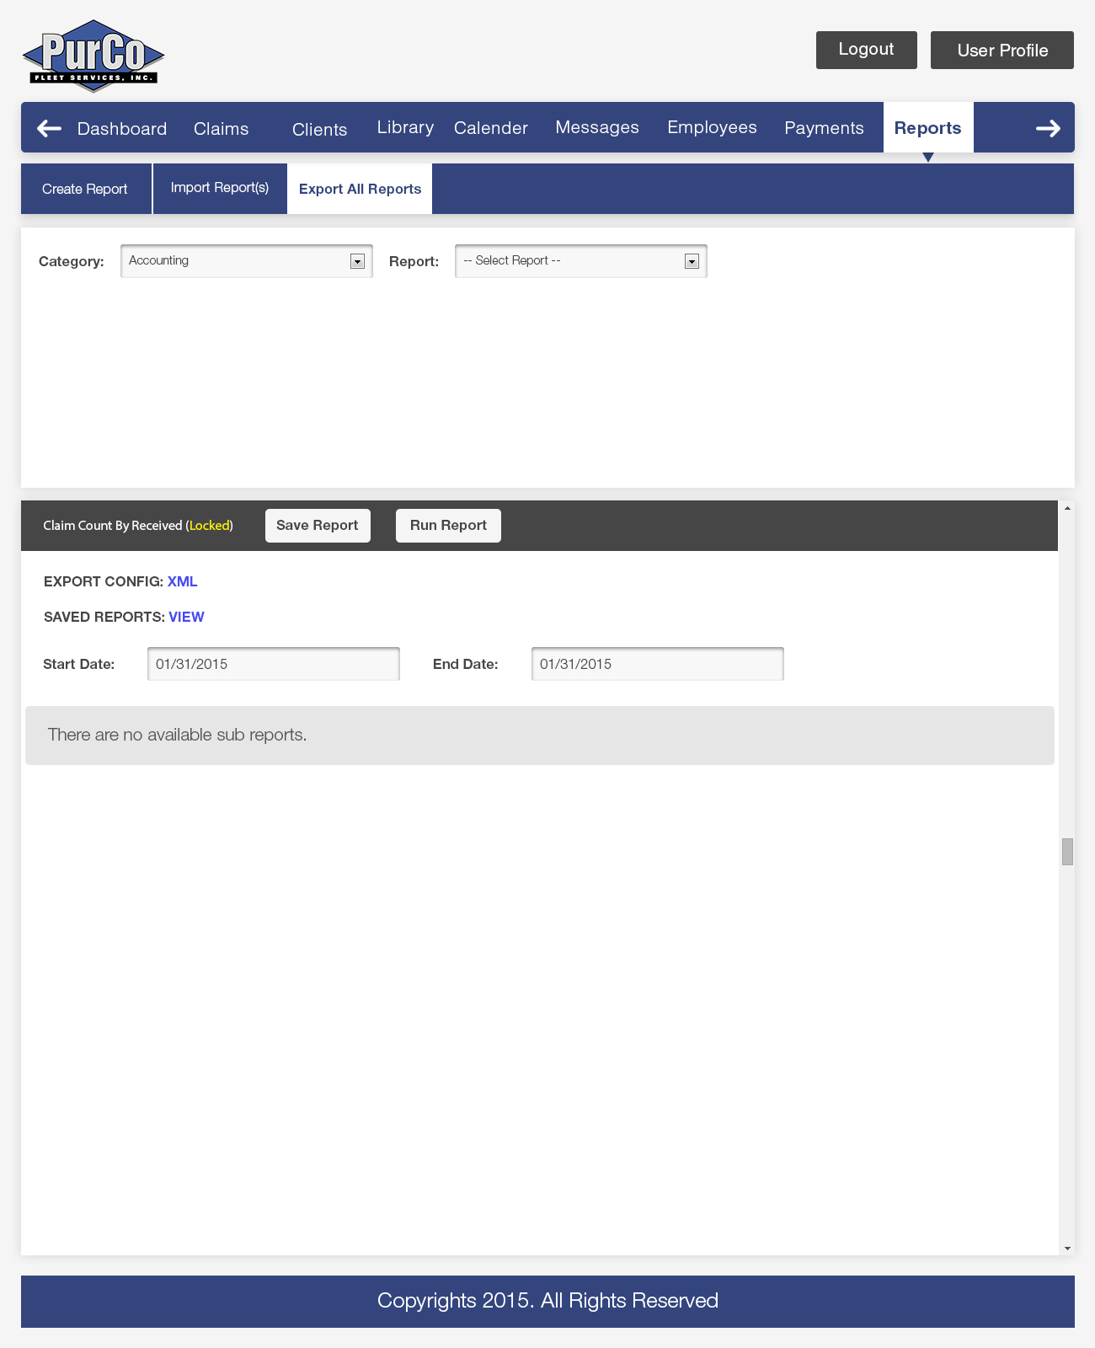

*Exhibit 3-1.26: Reporting Screen views covering existing features in CMS (Ref REP-1/2/3/4/5/6)*

## 3.1.13 CMS Configuration (Data Tables)

DATA-1: Manage System Configuration Data: The System shall provide a mechanism to

manage System configuration data. Management of System data shall

be governed by Permissions.

System configuration data includes:

1. Claim Statuses
2. Contact Information Values
3. Involved Party Information Values
4. Client Types
5. Statute of Limitations configuration
6. Address List for Suspension Letters
7. Amount Types
8. Payment Origins (Insurance / Renter / Etc)
9. Organization Types
10. Automobile Make and Models
11. General Journal Notes
12. Canned (predefined) Journal Notes

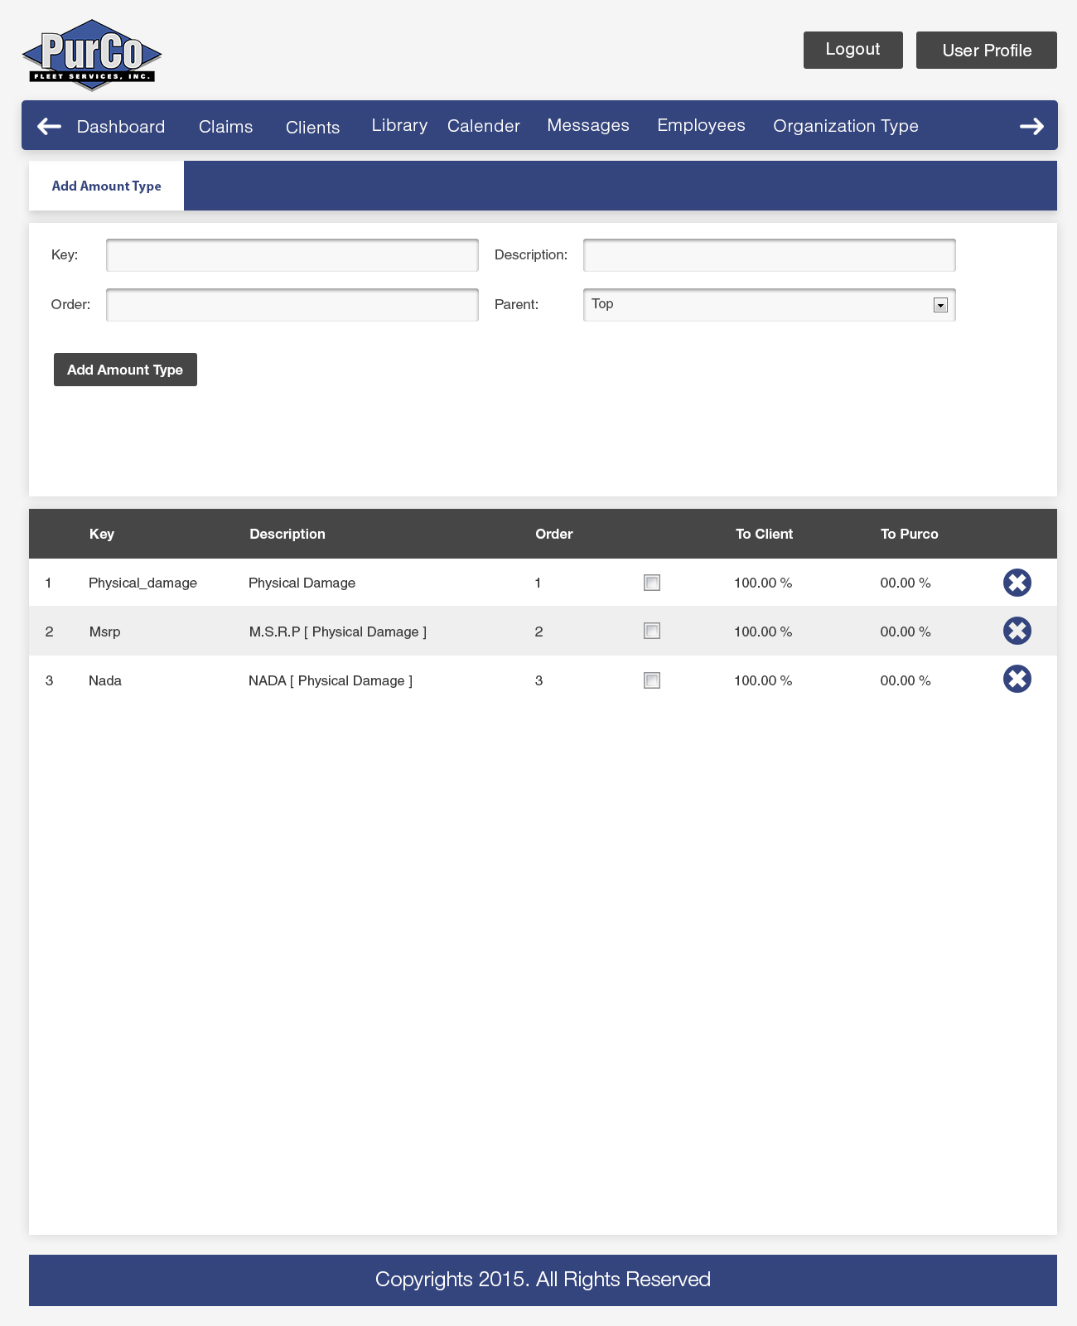

*Exhibit 3-1.27: Amount Types pop-up (Ref DATA-1)*



*Exhibit 3-1.28: Client Note Types pop-up (Ref DATA-1)*

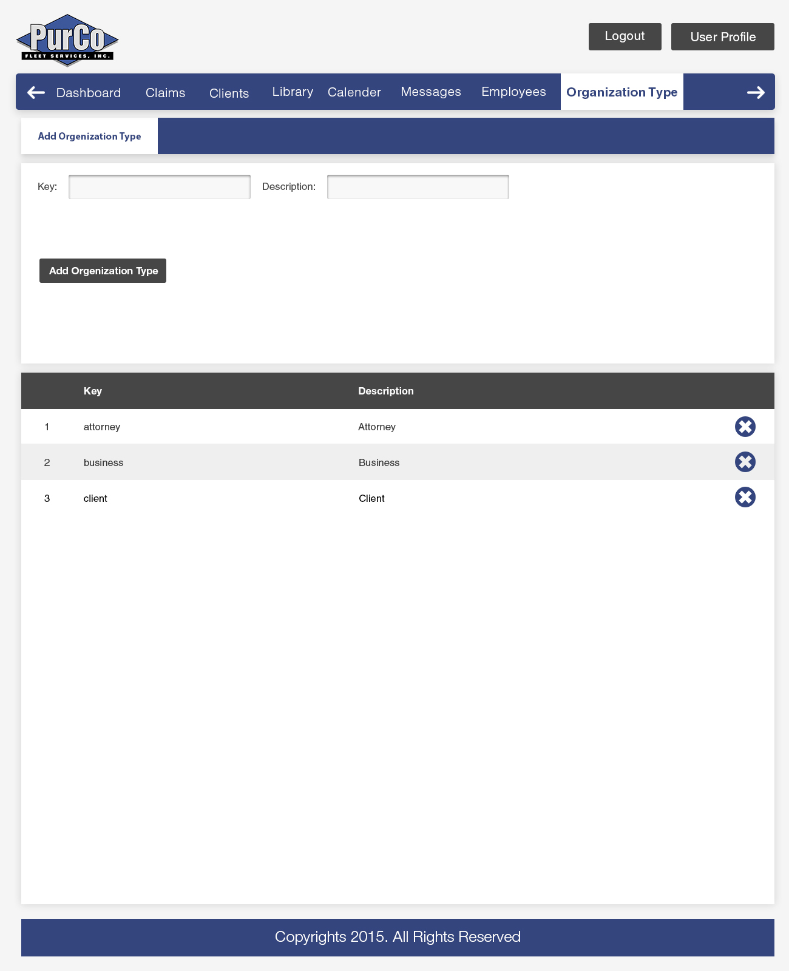

*Exhibit 3-1.29: Organization Types pop-up (Ref DATA-1)*

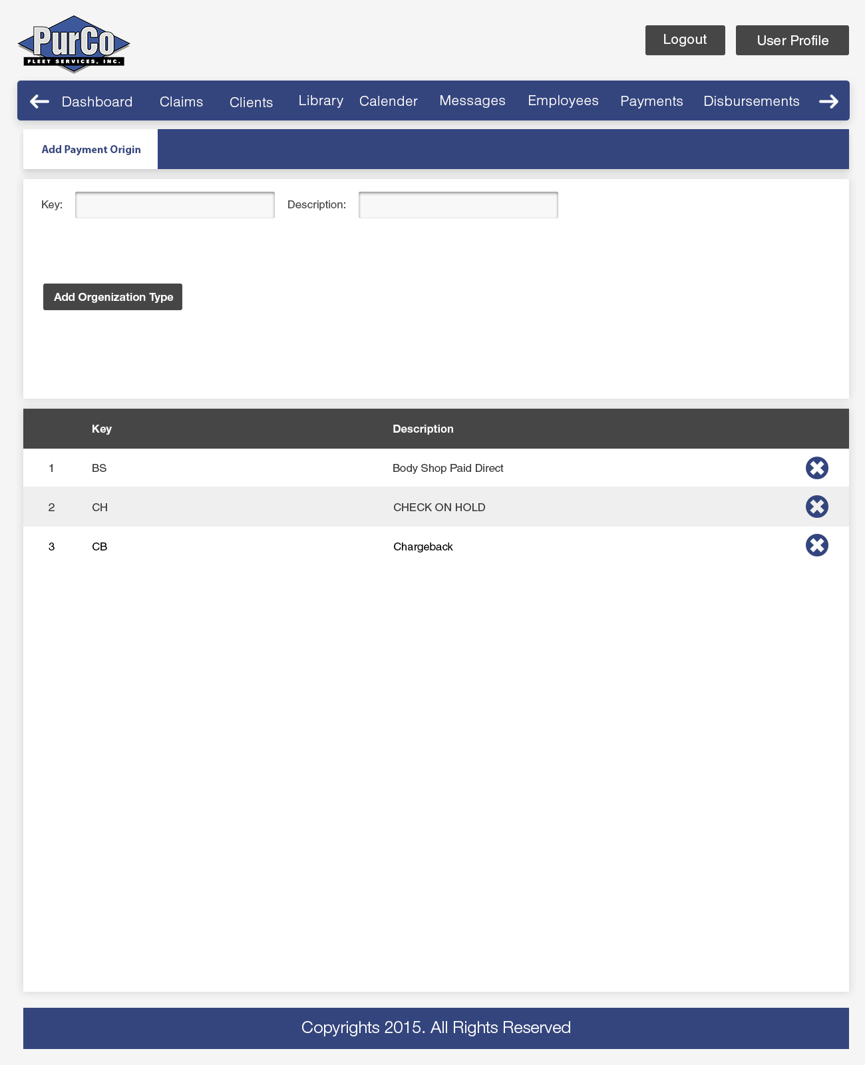

*Exhibit 3-1.30: Payment Origins pop-up (Ref DATA-1)*

## 3.1.14 User Roles and Permissions

PERM-1: The System shall provide a mechanism of fine grained Role Based Access

Control. The Permissions module shall control access to all objects in the

System.

PERM-2: Creation of Roles: The System shall provide a mechanism for creating Roles.

Roles are bundles of Permissions and are assigned to Users.

The following Roles will be created initially in the System:

1. System Administrator
2. Managers
3. Admin
4. Specialist
5. In-house Attorney
6. Client
7. Renter
8. Attorney

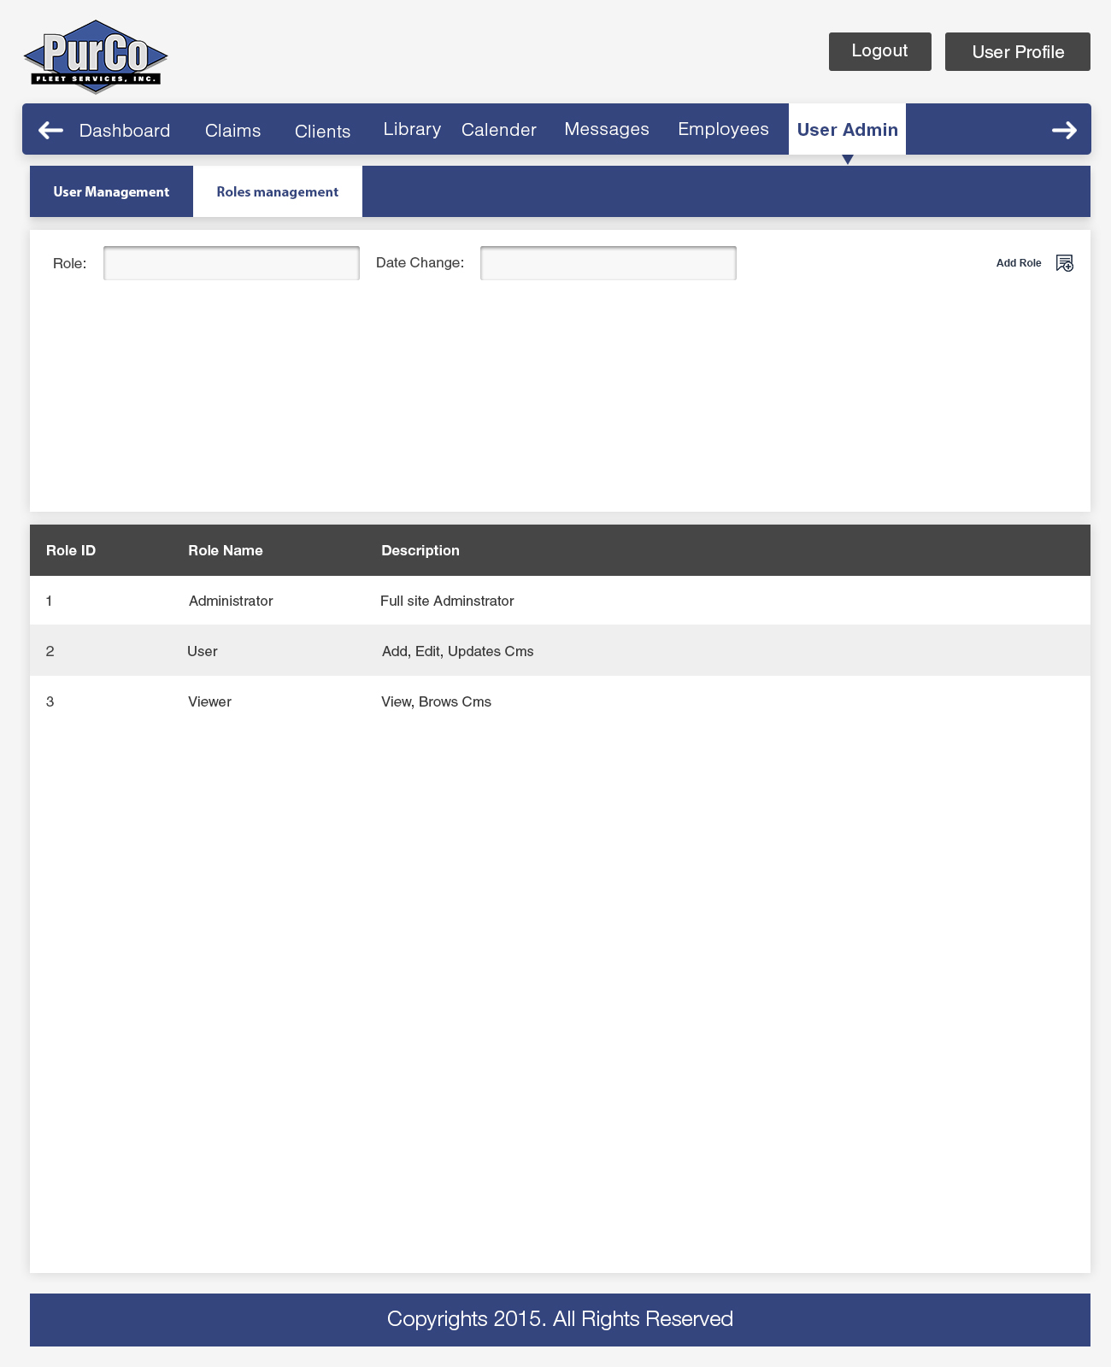

*Exhibit 3-1.31: CMS User Administration views for Role assignment/creation (Ref PERM-1, PERM-2)*

PERM-3: Creation of Permissions: The System shall provide a mechanism for creating

Permissions. Permissions grant operations on System objects.

PERM-4: Assignment of Permissions to Roles: The System shall provide a mechanism

for assigning and revoking Permissions for Roles.

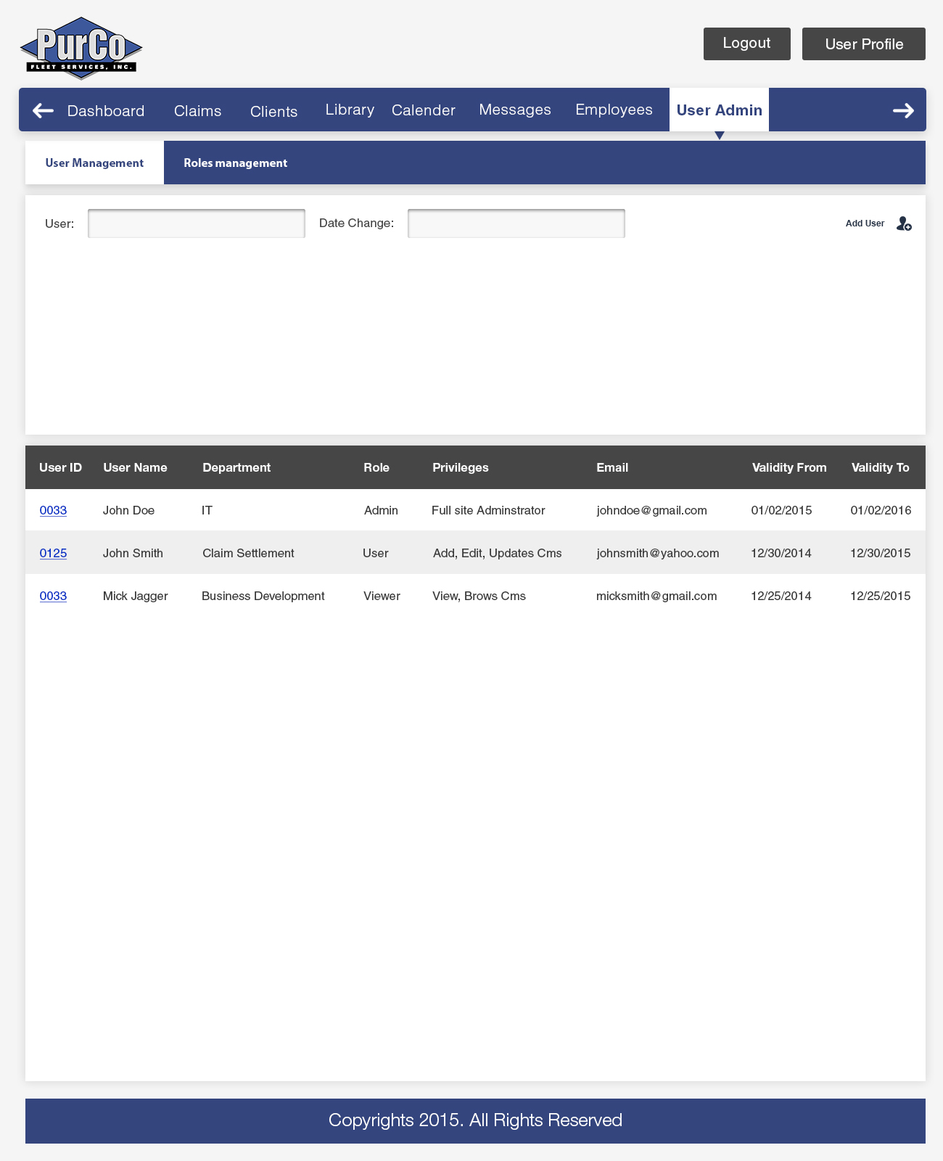

*Exhibit 3-1.27: CMS User Administration views for User Role assignment (Ref PERM-3, PERM-4)*

PERM-4: Assignment of Roles to Users: The System shall provide a mechanism for

assigning and revoking Roles for Users.

A Users full System Permissions are based upon the Roles that they have

been granted. Roles are granted by Administrator Users.

## 3.1.15 Payment Plans / Processing

PAYP-1: Batch Payments: The System shall provide a mechanism for processing

batch Payments. Process can consist of an export from Authorize.net for ARB

payments.

PAYP-2: Payment Plans: The System shall provide a mechanism for automating

tasks associated with Payment Plans.

Tasks associated with Payment Plans include:

1. Creation of Payment Coupons [TBD, see PAYP-5].
2. Arrears Letters.
3. Authorization for automatic credit card payments.

PAYP-3: Payment Plan Claim status integration: The System shall provide a

mechanism

for automatically launching the Payment Plan module in the case a Claim

status is changed to CT (CT will be clearly defined upon Discovery completion)

PAYP-4: Printing payment log: The System shall provide a mechanism for printing

a Payment Log (context may be Reporting)

PAYP-5: [SDI] Basic CT (Closed over Time) Module to allow for automated reminders

when a payment is about to be missed, missed, and after some time it has

been missed. Reminders may be over SMS, email, and other compatible

methods depending on what transports are available (creation of which may be

outside of this scope). Further discussion is

needed on payment books and their future at both PurCo and SDI.

4. External Interface Requirements

4.1 User Interfaces

## 4.1.0 General UI Improvements

UI-1: Auto-population of field values: Wherever possible, data entry fields

shall provide auto populated suggestions.

UI-2: Improved navigation: The UI will provide an improved experience when utilizing

back and forward navigation controls. Form values shall be persisted, and back

navigation operations will return the User to the previous logical screen. Tab order should be more logical with respect to order of field navigation.

UI-3: Highlighting in Notes: The System shall provide a mechanism for highlighting

sections of text within Notes with a limited pallette

UI-4 Calendar system should be more robust and allow for better management of

daily claim workload as well as shared attendance to better assign claims to CS who are present or scheduled.

UI-5 [SDI] Ability to embed and update State and regulatory information (ex. % of authority, Fee schedule, Loss Location, etc) into the CMS.

UI-6 [SDI & PurCo] Consolidated information banner for easier access to information that is critical in managing contact with related parties to a Claim.

UI-7 Optimize speed of new system for more responsive UI

## 4.1.1 Claim UI Improvements

UICLAIM-1: Improved tab ordering: Claim form UIs will have improved tab navigation which

facilitates efficient Claim entry.

UICLAIM-2: Improved Claim Entry: Claim UIs will have a more efficient method of entering

new Claims. The existing “New Claim” UI is slow.

UICLAIM-3: Efficient confirmation: The System shall provide the ability to efficiently send

confirmation of files directly from the CMS.

The confirmation shall include Claim and Specialist information. Verification of

the confirmation being sent will be recorded in the audit log.

UICLAIM-3: Default Involved Party: When adding an Involved Party on a Claim, the UI shall

default to ‘Third Party’, which is the most commonly entered Involved Party.

UICLAIM-4: Quick selection of claim codes: When changing a Claim’s status, the Claim

Status field will allow a User to select a Claim Status by short code as well as

the longer textual name.

As an example, A user may type CD to jump to the “Closed / Disbursed (CD)”

status.

## 4.1.2 Payment UI Improvements

UIPAY-1: Bulk update of Payment values: The System shall provide a mechanism for

updating certain Payment values of multiple Payments at once. User should be

able to select multiple records at once.

UIPAY-2: Auto-population of Payment values: When possible, the System shall auto

populate Payment fields with information from previous Payments made on the

Claim. This is to help support multiple Payments such as recurring Payments.

## 4.1.3 Statistics Module

STATS-1: The System shall provide a mechanism for calculating metrics of

Employee performance and efficiency.

## 4.1.4 Total Loss Module

LOSS-1: The System shall provide a mechanism for aiding in the management

of Total Loss claims.

The Total Loss module will track values pertaining to Total Loss such as:

1. VIN
2. Residual Value
3. MSRP
4. FMV
5. NADA

LOSS-2: Possible use of existing ‘Salvage Tab’, need to research feasibility of integration with ‘SalvageNow’ (in the CMS, you can go to Salvage Tab shows everyting about the car (book value, reserve price, etc.) button loads it into Salvage Now website. Optimally, client could also enter data on the website.

**4.1.5 PurCo.com Website**

WEBSITE-1: Clients will have the ability to login to the external facing website to access their

required resources (no site redesign, assuming interoperability based upon

current architecture) based upon login and account attributes

1. Client Resources
2. Administrative Fee Chart (reuse existing content)
3. PurCo Contacts (reuse existing content)
4. Claim Status Codes (reuse existing content)
5. Search Claims
6. Reports
7. Client Profile
8. Incident Entry
9. Email PurCo (reuse existing content)
10. LogOut

4.2 Hardware Interfaces

## 4.2.1 Phone Integration

PHONE-1: Phone recordings: The System shall provide a mechanism for attaching

recordings of phone calls. Due to limitations of the ACD, this will need to be

done using the current email of voicemail WAV file process.

PHONE-2: Claim identification based on Caller ID: The System shall provide a mechanism

of identifying claims based upon the Caller ID of the caller and Employee

called.

PHONE-3: IVR entry of Claim Number: The System shall provide a mechanism for

gathering Claim Number digits through the phone system.

The Claim Number entered shall populate the Employee’s CMS session with

a list of possible claims to pick from, and if possible, sorted with “Assigned

Agent” on top.

PHONE-4: Dial from CMS: The System shall provide a mechanism for dialing a phone

number directly from the CMS using the CBR (can be reached) data in the

Claim record. Every time a call is made or taken, a note is entered into the

Journal.

4.3 Software Interfaces

## 4.3.1 Payment System Integration

PSI-1: Zion Bank ACH: Research the ability to process batch ACH payments after they have been approved by the proper authority. This may require a new ACH processor or an update to the process method, but it will require API support. This is estimated to save 40 hours per week in labor.

PSI-2: Authorize.net automatic import: The System shall provide the ability to import

auto payments from Authorize.net. Research of the API is needed, but expected to be supported.

## 4.3.2 Fax Integration

FAX-1: Fax server: Desired solution will allow for easy integration into the consolidated Media Manager Service for parsing and sorting of fax information into the CMS.

## 4.3.3 Third Party Integrator Interfaces

INT-1: HROW API: Hertz of Ogden Utah has agreed to implement an updated

RESTful/JSON service according to a written spec we provide. The only

additional element they need other than the current functionality is the ability to

pass a value for “CompanyName”.

This service will be bi-directional with HROW able to retrieve a claim number

then send subsequent data for that claim ID directly into the CMS.

## 4.3.4 Email Integration

EMAIL-1: Email integration: The System shall provide a mechanism for integrating

information from emails into the System. Information from incoming emails

shall be associated to Claims, when adequate Claim information is included in

the emails. The goal is to create a Correspondence module within the CMS

that behaves like an email client but with better integration with named and

involved parties and route correspondence automatically (including

attachments and email body) to the proper Claim records.

4.4 Communications Interfaces

COMM-1: PDF Generator (Research solutions to make PDF creation a shared server side function and eliminate the need for Adobe Acrobat Pro on each machine)

COMM-2: End User Portal (Will need to define specically what the external users of the PurCo.com website will require beyond what is currently in place. There is no initiative to replace or update the website.)

Appendix A: TBD Items

Roles and Responsibilities

I/T: Jennifer Turner

Network: TBD

Telephony: YipTel, Jeff Limb